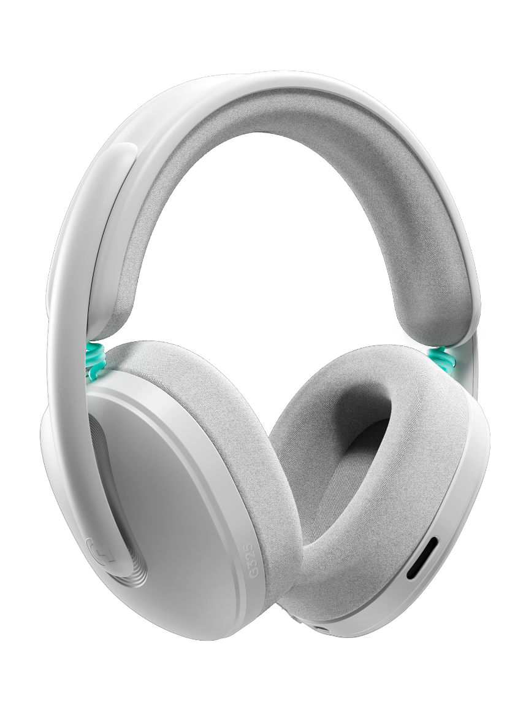
Logitech G G325 LIGHTSPEED Wireless Gaming Headset

Announcement Date: February 3, 2026
Price: €79.99 / 1 990 Kč
Available at: ČR – Datart, Smarty, Planeo
SK – NAY, Smarty

Product Description

The all-new gamer-grade Logitech G325 LIGHTSPEED Wireless Gaming Headset is designed for superior comfort and wireless play anywhere.

Featuring sleek aesthetics and innovative engineering, G325 radiates powerful simplicity with a design that is comfortable, versatile, and durable. The compact profile and understated look, combined with over 24 hours of continuous battery life, make this a comfortable companion for both all-day gaming sessions and laid-back listening.
With high-quality audio, a beamforming mic with AI-powered noise reduction, and audio customization options, G325 means personalized and immersive audio wherever you play.
Joining the popular Logitech G3 Series, G325 lets you get to the fun faster. It’s ready to go right out of the box. G3 series gear gives players the confidence to jump right into the game and play.
With professional-grade wireless performance, full-bodied audio, and all-day comfort–all at an attractive price–the Logitech G325 LIGHTSPEED Wireless Gaming Headset redefines expectations for value-driven gaming headsets, proving that “budget” no longer means compromise.
KEY FEATURES
- Effortless Comfort & Streamlined Style – A modern, flattering design with a close-fit headband, breathable fabrics, and dual-layer memory foam ear cups. Sleek on your desk, stylish on your head, you’ll look sharp and stay cool through every gaming session.
- 24-Bit Audio - A signal range that delivers more dynamic sound, which means richer, fuller, and better-sounding audio with immersive bass.
- Crystal-Clear Voice – Built-in beamforming mic with AI-powered noise reduction that minimizes fan hums, keyboard clacks, and other ambient noises.
- LIGHTSPEED Wireless – Fast, reliable, pro-grade connection for seamless play and versatility. With up to 30 meters of wireless range you can stretch, snack, or pace without losing the action.
- Powerful Software Customization – Express yourself in your audio with a 10-band EQ or select from game-optimized presets, all available with G HUB software or the mobile app.
- All-Day Power – Over 24 hours of battery life on LIGHTSPEED wireless so the marathon only ends when you say so.
- Versatile Connection with Bluetooth – Connect to more devices and play, listen to music, and chat with friends at home or on the go.

Headphone
- Audio Drivers: 32 mm
- Frequency Response: ~20 kHz

Microphone
- Pickup pattern: Omni
- Signal processing: Dual beamforming mic with optional AI-powered noise reduction
- Frequency response: 100Hz-7kHz

Wireless Technology
- LIGHTSPEED Wireless @ 24-bit/48 kHz
- Up to 30 meters via LIGHTSPEED
- Bluetooth® ver 5.3

Physical Specifications
- Height: 7.63 in (194mm)
- Width: 7.36 in (187 mm)
- Depth: 3.19 in (81 mm)
- Weight: 7.48 oz (212 g)

Battery Life
- Battery (rechargeable), up to 24 hrs

System Requirements
- For LIGHTSPEED:
  - Windows, macOS, Switch 1 and 2, or PS4/PS5 with an available USB 2.0 port.
- For Bluetooth® connection:
  - Compatible with devices supporting Bluetooth® 5.0 or greater.
- Additional software:
  - Please visit www.logitechG.com/ghub for compatibility.

Sustainability
G325 is made with recycled plastic and responsible (zero plastic) packaging. It features an optimized architecture, designed for lightweight comfort and sustainability. Some key sustainability features include:
- Optimized inner components (PCB) that eliminate superfluous coatings and a lightweight design (only 7.48 oz (212 g)) that uses less plastic in streamlining its shape for greater comfort.
- An optional 80% battery charge limit (accessible via G HUB software) to help extend battery lifespan.
- Certification using the highest validated percentage of post-consumer recycled (PCR) plastics up to 46%.

Options Available
Style blends with game-ready performance and clean aesthetics to complement various lifestyles and playstyles. G325 is available in three colorways: Black with a touch of purple, White with a hint of mint, and Lilac accented with orange.

What’s in the Box
G325 LIGHTSPEED Wireless Gaming Headset
LIGHTSPEED Wireless Receiver (USB-A)
USB-C to USB-A Charging Cable
User Documentation

