Fact Sheet

Logitech® G203 LIGHTSYNC Gaming Mouse
Affordable gaming performance.
Announcement Date: April 21, 2020 Shipping: April 2020
Price: 1 109 Kč Available at: LogitechG.com

Product Description
The Logitech® G203 LIGHTSYNC Gaming Mouse delivers gaming-grade performance and a classic design at an affordable price. It can be used directly out-of-the-box, or fully configured using Logitech Gaming Software. Choose from a palette of up to 16.8 million colors and different brightness levels to match your style, system or environment. Configure any of the six buttons to simplify in-game actions and save your preferences to the onboard memory and easily use it on any PC.

Key Features
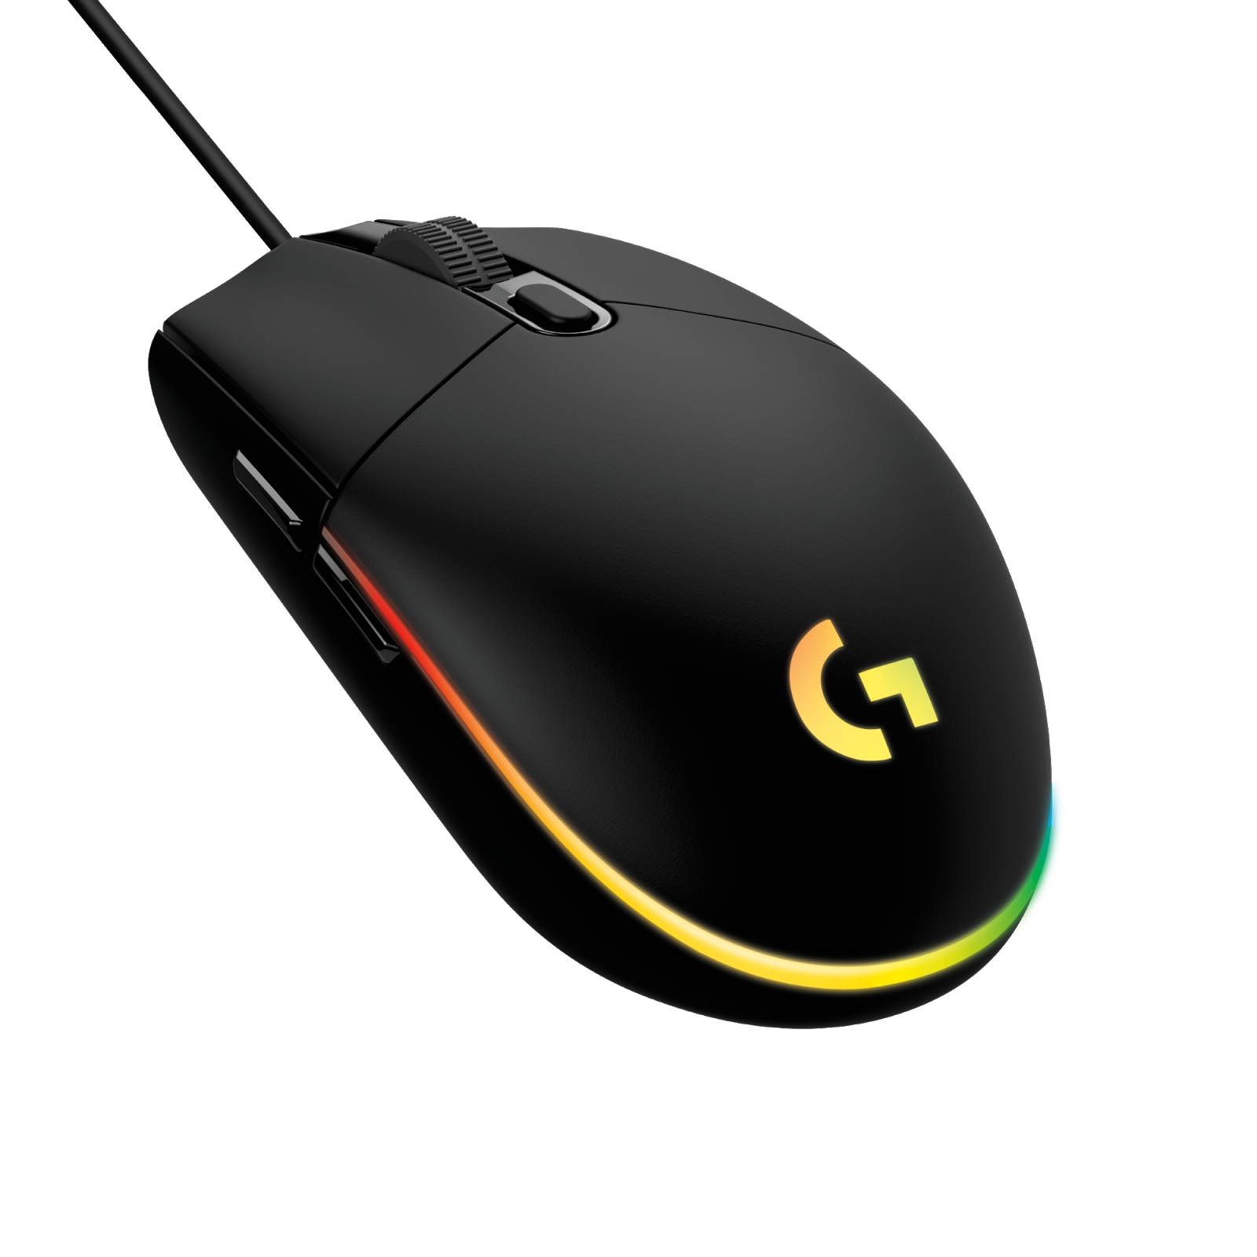
- Affordable Gaming-Grade Performance: Time-tested 6-button design with programmable buttons using Logitech G HUB Software. The gaming mouse communicates at up to 1,000 reports per second – eight times faster than standard mice – so that when the mouse is moved or clicked, on-screen response is near-instantaneous. Advanced button tensioning further refines the experience by keeping the left and right mouse buttons primed to click and delivering exceptional click feel, response and consistency.
- LIGHTSYNC RGB Lighting: Customizable LIGHTSYNC RGB with a rainbow color wave effect with approximately 16.8 million colors. Lighting, commands and game macros are customizable through Logitech G HUB*.
- Gaming-Grade Sensor: Gaming-grade sensor with adjustable DPI up to 8000 DPI delivers excellent accuracy and consistency.

System Requirements
- USB port and Windows® 7 or later, Mac OS X 10.11 or later, or Chrome OS™
- (Optional) Internet access for Logitech G HUB*

Physical Specifications
- Height: 4.59 in (116.6 mm)
- Width: 2.45 in (62.15 mm)
- Depth: 1.50 in (38.2 mm)
- Weight: 85 g

Tracking
- Sensor: Gaming Grade Sensor
- Resolution: 200 - 8,000 DPI

Responsiveness
- USB data format: 16 bits/axis
- USB report rate: 1000Hz (1ms)
- Microprocessor: 32-bit ARM

Warranty
- 2-year limited hardware warranty

Press Contact
Leona Daňková
TAKTIQ COMMUNICATIONS s.r.o.
+420 605 228 810
leona.dankova@taktiq.com

*Advanced features require Logitech G HUB. Download at LogitechG.com/downloads.

