Fact Sheet

Logitech® G604 LIGHTSPEED Wireless Gaming Mouse
Make your play.

Announcement Date: Sept. 16, 2019 Shipping: September 2019
Price: 2 769 Kč Available at: LogitechG.com

Product Description
Designed for fans of Battle Royale, Massive Multiplayer Online (MMO) and Multiplayer Online Battle Arena (MOBA) games, the Logitech® G604 LIGHTSPEED Wireless Gaming Mouse helps multiplayer gamers get the best performance with 15 programmable controls, including a six-pack of thumb buttons. Featuring Logitech G’s best-in-class HERO (High-Efficiency Rated Optical) 16K sensor, the G604 LIGHTSPEED offers an amazing 240 hours of high-performance wireless gaming on LIGHTSPEED™ Wireless and up to 5.5 months on Bluetooth® - all on one AA battery. Conveniently switch wireless connectivity and toggle between two different machines using one mouse with a push of a button.

Key Features
- Next-Generation LIGHTSPEED Wireless Technology: Logitech G’s award-winning LIGHTSPEED Wireless provides a faster-than-wired gaming experience with a 1 ms report rate, end-to-end optimized wireless connection and incredible responsiveness. Connect using LIGHTSPEED for the fastest wireless performance and advanced features, or Bluetooth to pair with multiple devices.
- Industry-Leading HERO 16K Sensor: The most efficient gaming sensor available, Logitech G’s exclusive HERO 16K consumes 10x less power than previous generations, providing 240 hours of high-performance wireless gaming on LIGHTSPEED Wireless and up to 5.5 months of battery life on Bluetooth - all on one AA battery. It delivers incredible performance with exceptional accuracy and responsiveness, zero smoothing, 400 IPS precision and sensitivity up to 16,000 DPI.
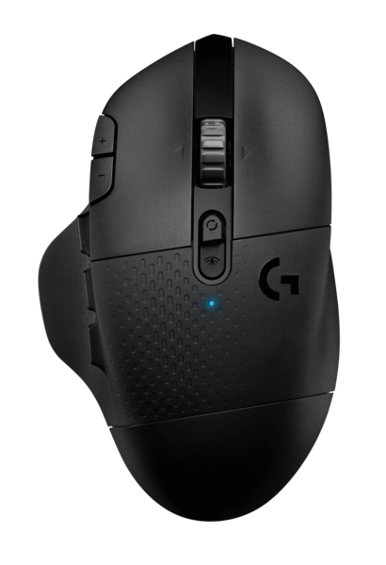
- Customizable for Non-Stop Gaming: The customizable G604 mouse features 15 programmable controls, a dual-mode hyper-fast scroll wheel and a six-pack of thumb buttons. To help gamers get the most from their gear, the G604 LIGHTSPEED can be programmed using Logitech’s G HUB gaming software.
- Multi-Device Connectivity: Connect to one PC via LIGHTSPEED receiver and another through Bluetooth. Easily switch between the two devices with a press of a button.

System Requirements
- LIGHTSPEED™: USB port and Windows® 7 or later, macOS® 10.12 or later, Chrome OS™, or Android™ 3.2 or later
- Bluetooth®: Bluetooth-enabled device with Windows® 8 or later, macOS® 10.12 or later, Chrome OS™, or Android™ 5.0 or later
- (Optional) Internet access for Logitech G HUB*
Physical Specifications
- Dimensions (L x W x D): 130 mm x 80 mm x 45 mm
- Weight: 135g

Tracking
- Sensor: HERO 16K
- Resolution: 100 – 16,000 DPI
- Max. acceleration: > 40G
- Max. speed: > 400 IPS
- Zero smoothing/acceleration/filtering

Responsiveness
- USB data format: 16 bits/axis
- LIGHTSPEED Wireless report rate: 1000 Hz (1 ms)
- Bluetooth report rate: 88-133 Hz (7.5-11.25 ms)
- Microprocessor: 32-bit ARM

Durability
- PTFE feet: > 250-km range

Battery Life
- LIGHTSPEED mode: up to 240 hours (non-stop gaming)
- Bluetooth mode: up to 5.5 months (standard usage)

Other features
- Dual mode hyper-fast scroll wheel
- Onboard memory
- Mechanical Button Tensioning System

Warranty
- 2-year limited hardware warranty

Press Contact
Leona Daňková
TAKTIQ COMMUNICATIONS s.r.o.
+420 605 228 810
leona.dankova@taktiq.com

*Advanced features require Logitech G HUB. Download at LogitechG.com/GHUB.

