Logitech® G915 LIGHTSPEED™ Wireless Mechanical Gaming Keyboard
The ultimate wireless gaming keyboard.

Announcement Date: Aug. 15, 2019 Shipping: August 2019
Price: €249 Available at: LogitechG.com

Product Description
The Logitech® G915 LIGHTSPEED™ Wireless Mechanical Gaming Keyboard was designed and engineered to be the most advanced and innovative keyboard imaginable. With its ultra-thin design and new low-profile GL Switches, combined with Logitech G’s industry-leading LIGHTSPEED Wireless technology, advanced LIGHTSYNC™ RGB and amazing 30-hour battery life, all packaged in a sleek, ultra-thin, aluminum finish, the G915 LIGHTSPEED brings a new dimension of gameplay.

Key Features
- Pro-Grade LIGHTSPEED Wireless Technology: The G915 LIGHTSPEED provides a super-fast 1 ms report rate and end-to-end optimized wireless connectivity. Get LIGHTSPEED performance and a clean, wire-free aesthetic for battlestations.
- High-Performance, Low-Profile GL Switches: Making their debut, Logitech G’s low-profile GL Switches are half the height of standard mechanical key switches for 25 percent faster actuation** and a more comfortable typing experience. Choose from GL Linear, GL Tactile or GL Clicky switches to match play preferences. The tactile version gives discernible actuation for gamers who prefer direct feedback, while the linear version provides a smooth keystroke. The clicky version offers a much-requested audible typing experience with tactile feedback.
- Impressive 12-Days of Battery Life: Enjoy 12 days of gaming with RGB colorwave turned on – 135 days with RGB lighting turned off*** - and only three hours required to recharge for full battery. Connect to LIGHTSPEED Wireless or swap to another device with the push of a button using Bluetooth® connectivity. Toggle between high-performance LIGHTSPEED Wireless and Bluetooth quickly and easily.
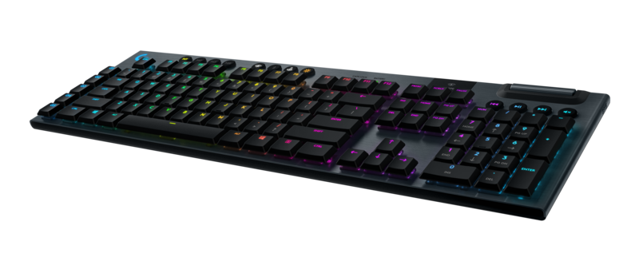
- LIGHTSYNC RGB Technology with Per-Key Customization: Next-generation RGB synchronizes lighting with on-screen gaming and entertainment content. Personalize lighting for each individual key, customize animations and experience in-game integrations from across approximately 16.8 million colors using Logitech G HUB software*.
- Sleek, Ultra-Thin Design: Impossibly thin and light, the G915 LIGHTSPEED meticulously blends a sophisticated aluminum top case design with cutting edge technologies. Three onboard profiles and five dedicated G-keys can be programmed with up to 15 custom macros and in-app commands through Logitech G HUB*. A precision engineered edgeless volume roller and dedicated media keys provide simple and intuitive control to quickly play, pause, skip or mute.

System Requirements
- LIGHTSPEED: USB port and Windows® 7 or later, macOS® X 10.11 or later
- Bluetooth®: Bluetooth enabled device with Windows® 8 or later, macOS® X 10.11 or later, Chrome OS™, or Android™ 4.3 or later, iOS 10 or later
- (Optional) Internet access for Logitech G HUB*

Technical Specifications
- GL Tactile Switch
  - Feedback Type: Discernable
  - Actuation Distance: 1.5mm
  - Actuation Force: 50gf
  - Total Travel Distance: 2.7mm
- GL Linear Switch
  - Feedback Type: Smooth
  - Actuation Distance: 1.5mm
  - Actuation Force: 50gf
  - Total Travel Distance: 2.7mm
- GL Clicky Switch
  - Feedback Type: Audible and Tactile
  - Actuation Distance: 1.5mm
  - Actuation Force: 50gf
  - Total Travel Distance: 2.7mm
- Battery Life: 30 hours

Physical Specifications
- Length: 475mm (18.7 in)
- Width: 150mm (5.9 in)
- Height: 22mm (0.9 in)
- Weight (w/o cable): 1025g (36.2oz)
- Cable Length: 18m (6 ft)

Warranty
- 2-year limited hardware warranty

Press Contact
Leona Daňková
TAKTIQ COMMUNICATIONS s.r.o.
+420 605 228 810
leona.dankova@taktiq.com

*Advanced features require Logitech G HUB Advanced Gaming Software. Download at LogitechG.com/GHUB.
** Compared to. 2.0mm actuation in standard switches.
*** Assumes eight hours of continuous gaming per day.

