Logitech® G815 LIGHTSYNC™ RGB Mechanical Gaming Keyboard
The ultimate gaming keyboard.

Announcement Date: Aug. 15, 2019 Shipping: August 2019
Price: €199 Available at: LogitechG.com

Product Description
The Logitech® G815 LIGHTSYNC™ RGB Mechanical Gaming Keyboard meticulously blends a sophisticated aluminum top case design with cutting edge technologies. With its ultra-thin design and new low-profile GL Switches, the new gaming keyboard was designed and built to be the most advanced and innovative keyboard imaginable. Combined with Logitech G’s advanced LIGHTSYNC RGB in a sleek, ultra-thin package, the G815 LIGHTSYNC redefines keyboard design and engineering practice.

Key Features
- High-Performance, Low-Profile Mechanical GL Switches: Get the speed, accuracy and performance of a mechanical switch in a low profile design that is half the traditional height of standard mechanical key switches with Logitech G’s new low-profile GL Switches. Providing 25 percent faster actuation** and a more comfortable typing experience, choose from GL Linear, GL Tactile or GL Clicky switches to match play preferences. The tactile version gives discernible actuation for gamers who prefer direct feedback, while the linear version provides a smooth keystroke. The clicky version offers a much-requested audible typing experience with tactile feedback.
- Per-Key Customization with LIGHTSYNC RGB Technology: Logitech G’s next-generation RGB technology synchronizes lighting with on-screen gaming and entertainment content. Customize lighting for each individual key, create custom animations and experience in-game integrations from across approximately 16.8 million colors through Logitech G HUB software*.
- Impossibly Thin and Light Design: Three onboard profiles and five dedicated G-keys can be programmed with up to 15 custom macros and in-app commands using Logitech G HUB*. A precision engineered edgeless volume roller and dedicated media keys provide simple and intuitive control to quickly play, pause, skip or mute.
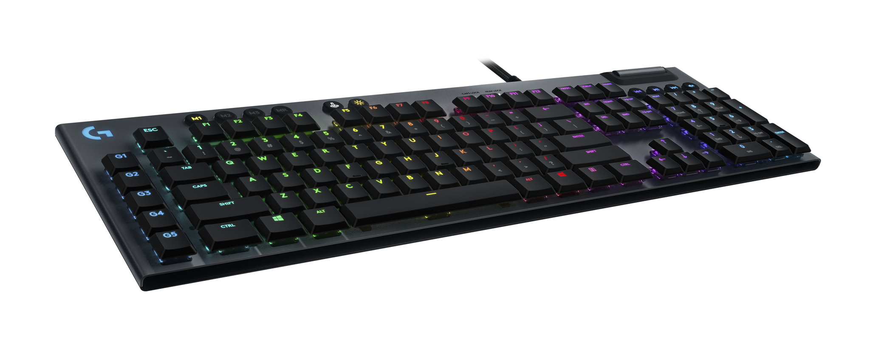
- Integrated USB Passthrough Port: A dedicated USB cable connects the USB 2.0 passthrough port to its own input for 100 percent power throughout. Plug in a third party device or Logitech G mouse to charge up and enter a new dimension of gameplay, without missing a moment.
- Logitech G HUB*: Logitech G HUB gives players unprecedented and easy control over their gear and games. Players can fine tune gear settings by game, connect to third party apps, and download and share custom game profiles with the Logitech G HUB community.
System Requirements
- 2 x USB ports (1 for keyboard, 1 for USB passthrough)
- Windows® 7 or later, macOS® X 10.11 or later
- (Optional) Internet access for Logitech G HUB*

Technical Specifications
- GL Tactile Switch
  - Feedback Type: Discernable
  - Actuation Distance: 1.5mm
  - Actuation Force: 50gf
  - Total Travel Distance: 2.7mm
- GL Linear Switch
  - Feedback Type: Smooth
  - Actuation Distance: 1.5mm
  - Actuation Force: 50gf
  - Total Travel Distance: 2.7mm
- GL Clicky Switch
  - Feedback Type: Audible and Tactile
  - Actuation Distance: 1.5mm
  - Actuation Force: 50gf
  - Total Travel Distance: 2.7mm

Physical Specifications
- Length: 475mm (18.7 in)
- Width: 150mm (5.8 in)
- Height: 22mm (0.9 in)
- Weight (w/o cable): 1045g (36.9 oz)
- Weight (w/cable): 1145g (40.4 oz)
- Cable Length: 1.8m (6 ft)

Warranty
- 2-year limited hardware warranty

Press Contact
Leona Daňková
TAKTIQ COMMUNICATIONS s.r.o.
+420 605 228 810
leona.dankova@taktiq.com

*Advanced features require Logitech G HUB Advanced Gaming Software. Download at LogitechG.com/GHUB.
** Compared to. 2.0mm actuation in standard switches.

