Logitech® G PRO X Gaming Headset
Hear like a PRO. Sound like a PRO.
Announcement Date: July 9, 2019 Shipping: July 2019
Price: €129 Available at: LogitechG.com

Product Description
Designed in collaboration with top esports athletes worldwide, the Logitech G PRO X Gaming Headset is engineered for the highest performing sound and voice technology, so all gamers can hear and sound like a PRO. The newest addition to the Logitech G PRO lineup of gaming gear marks the debut of Blue VO!CE software, offering clean, professional voice communication for competitive gamers and streamers. Compatible with PC and mobile devices, the lightweight PRO X features Logitech G’s exclusive Pro-G 50mm Audio drivers, DTS Headphone:X® 2.0 surround sound, a detachable pro-grade condenser microphone and both memory foam leatherette and velour earpads for incredible comfort.

Key Features
- Blue VO!CE Software: Developed in partnership with the industry-leading expertise of Blue Microphones, the next-generation BLUE VO!CE software is a suite of advanced microphone filters enabled using Logitech G HUB*. To sound great whether gaming or streaming, quickly select a preset filter profile with the integrated recording and playback function based on unique voice tone and volume. Advanced mode offers a full set of additional pro-grade filters for another level of customization, including a compressor, de-esser, de-popper and noise gate.
- PRO Driven Design: Created in cooperation with top esports athletes from all over the world to fit their rigorous training and travel schedules, the lightweight design is constructed from aluminum and steel, and features a detachable microphone, mobile cable and travel bag. Athlete involvement ensured features needed for intense competition were included, without adding distractions.
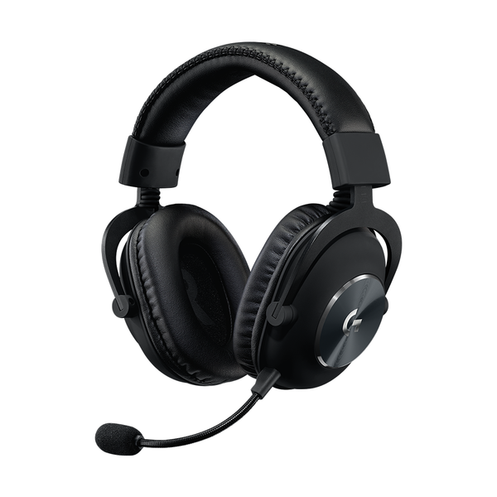
- Highly Cinematic Audio: Logitech G’s 50mm Pro-G Audio drivers are crafted from hybrid mesh materials that bend to the shape of sound waves for more precise audio, with deeper bass and a rounder sound profile. DTS Headphone:X 2.0 immersive audio technology stimulates the 3D environment of the audio’s original mixing stage.
- Ultimate Comfort: Comfortable enough to wear for hours, while still providing high durability and passive noise isolation, premium leatherette and velour-covered earpads with memory foam padding are both included.
System Requirements
- Windows® 7 or later, macOS 10.10 or later
- (Optional) Internet access for Logitech G HUB*
- USB port, 3.5 mm audio port or RCA audio output ports

Technical Specifications
- Headphone:
  - Driver: 50mm Pro-G
  - Frequency Response: 20Hz-20KHz
  - Impedance: 35 ohm
  - Sensitivity: 91.7 dB SPL @ 1mW & 1 cm
- Microphone:
  - Microphone Pickup Pattern: Cardioid (Unidirectional)
  - Condenser Size: 6mm electret
  - Frequency response:100Hz–10KHz

Physical Specifications
- Length: 138 mm (5.43 in)
- Width: 94 mm (3.70 in)
- Height: 195 mm (7.67 in)
- Weight (w/o cable): 320 g (11.28 oz)
- PC Cable Length: 2 m (6.56 ft)
- Mobile Cable Length:1.5 m (4.92 ft)

Warranty
- 2-year limited hardware warranty

Kontakt pro média:
Leona Daňková
TAKTIQ COMMUNICATIONS s.r.o.
+420 605 228 810
leona.dankova@taktiq.com

*Advanced features require Logitech G HUB. Download at LogitechG.com/GHUB.

