Logitech® G PRO Gaming Headset
Designed with PROs. Engineered to win.
Announcement Date: July 9, 2019 Shipping: July 2019
Price: €99.99 Available at: LogitechG.com

Product Description
Designed in collaboration with top esports athletes from all over the world, the Logitech G PRO Gaming Headset is engineered for esports-quality audio performance for competitor gamers. The lightweight gaming headset is compatible with PC and mobile devices, and features Logitech G’s 50mm Pro-G Audio drivers for highly cinematic audio, a detachable pro-grade condenser microphone for crystal-clear communication and soft, memory foam leatherette earpads for incredible comfort and noise isolation.
Key Features
- PRO Driven Design: Built in cooperation with top esports athletes worldwide to fit their rigorous training and travel schedules, the lightweight design features a detachable microphone and premium leatherette-wrapped headband. Athlete involvement ensured features needed for intense competition were included, without adding distractions.
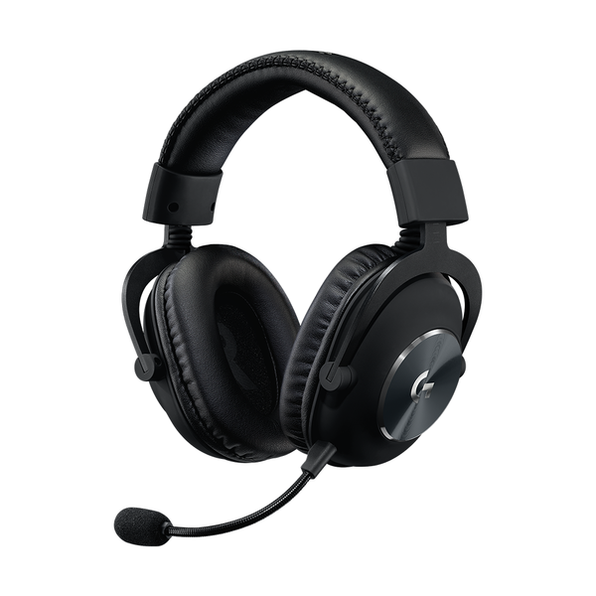
- High-Quality Audio: Logitech G’s exclusive Pro-G 50mm Audio drivers are crafted from a hybrid mesh material that bends to the shape of sound waves for more precise audio, with even deeper bass and a rounder sound profile.
- Ultimate Comfort: The aluminum, steel and leatherette design is comfortable enough to wear for hours, while still providing high durability. Premium leatherette earpads with memory foam padding offer maximum passive noise isolation, while improving sound clarity and volume.

System Requirements
- Windows® 7 or later, macOS 10.10 or later
- (Optional) Internet access for Logitech G HUB*
- USB port, 3.5 mm audio port or RCA audio output ports

Technical Specifications
- Headphone:
  - Driver: 50mm Pro-G
  - Frequency Response: 20Hz-20KHz
  - Impedance: 35 ohm
  - Sensitivity: 91.7 dB SPL @ 1mW & 1 cm
- Microphone:
  - Microphone Pickup Pattern: Cardioid (Unidirectional)
  - Condenser Size: 6mm electret
  - Frequency response:100Hz–10KHz

Physical Specifications
- Length: 138 mm (5.43 in)
- Width: 94 mm (3.70 in)
- Height: 195 mm (7.67 in)
- Weight (w/o cable): 320 g (11.28 oz)
- PC Cable Length: 2 m (6.56 ft)

Warranty
- 2-year limited hardware warranty

Kontakt pro média:
Leona Daňková
TAKTIQ COMMUNICATIONS s.r.o.
+420 605 228 810
leona.dankova@taktiq.com

*Advanced features require Logitech G HUB. Download at LogitechG.com/GHUB.

