FACT SHEET
Ultimate Ears BOOM 3
Built for extremes with balanced 360° sound, deep bass and serious durability. Drop proof, waterproof and sandproof with a Magic Button for one-touch music controls.

Announcement Date: August 30, 2018 Shipping: September 2018
Price: US: $149.99 Available at: www.ultimateears.com

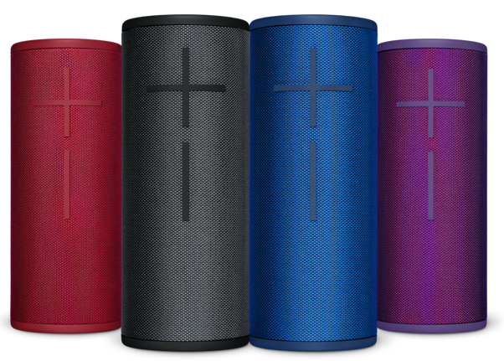
Product Description
Your ultimate adventure buddy just got better. The next generation Ultimate Ears BOOM 3 features the deep bass and 360° sound you love, carefully balanced so you can hear every note as the artist intended. Tougher than ever before, BOOM 3 is drop proof, waterproof and dustproof (IP67) with an impressive 15-hour battery life, wrapped in a two-tone, high-performance fabric so no matter the location, you can bring the party with you. Plus, with the new Magic Button for one-touch music controls, you can play, pause and skip songs directly on the speaker without ever reaching for your phone. A repositioned USB port means the speaker stays upright while charging. And, now, you can use the the Ultimate Ears POWER UP charging dock for convenient, wire-free charging.

Key Features
- Ultimate Sound: Just like previous generations, BOOM 3 is packed with carefully balanced 360-degree sound that lets you hear every note just as the artist intended.
- Stunning Two-Tone, High-Performance Fabric: Dual-toned, high-performance fabric developed from the ground up looks as stunning as it is tough for richly saturated iridescent themes and uncompromised performance that can take on life with you.
- One-Touch to Music with Magic Button: The freshly introduced Magic Button on top of BOOM 3 means you’re just one touch from your favorite Apple Music (on iOS) and Deezer Premium (on Android) playlists when paired with the BOOM 3 and MEGABOOM 3 by Ultimate Ears mobile app. No more fishing your phone in a bag or navigating menus to find what you’re looking for - simply play, pause and skip tracks directly on the speaker. You can also long-press to power up playlists and even skip to different playlists.
- Seriously Tough with an Impressive 15-Hour Battery Life: BOOM 3 pumps out amazing sound in a virtually indestructible package. Having withstood more than 25 seriously tough durability tests, it’s not only drop proof and waterproof, but now we’ve made it dustproof thanks to a new IP67 rating, plus it can float. BOOM 3 handles any adventure with a battery life of up to 15 hours.
- Extended Bluetooth Range and Portability: BOOM 3 now has a range of 150 feet on Bluetooth, whereas BOOM 2 had 100 feet. An added hanging loop further increases portability.
- Redesigned App: A redesigned app for BOOM 3 offers all of the features you love from previous speakers like PartyUp—which works with all generations of BOOM and MEGABOOM and allows you to connect up to 150 speakers—as well as a custom equalizer (EQ), and remote on/off controls. Plus, you can pair the app with the Magic Button to get to your Apple Music or Deezer Premium playlists even faster.
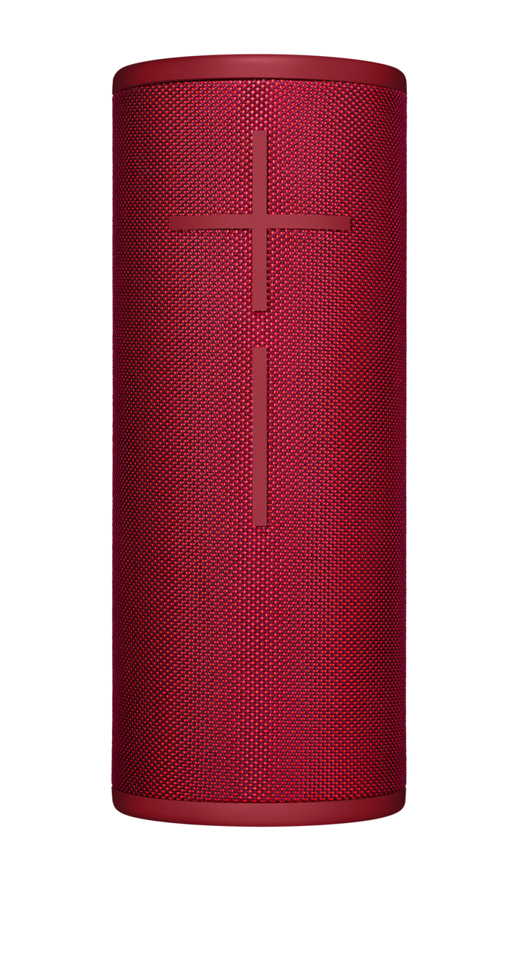
System Requirements
- Mobile device that supports Bluetooth with advanced audio distribution profile (A2DP)
- BOOM 3 and MEGABOOM 3 by Ultimate Ears app for iPhone on App Store and for Android™ on Google Play

Product Specifications
- Height: 184mm height mm, Diameter: 73mm, Weight: 608g
- Wireless capabilities: pair up to 8 Bluetooth® enabled source devices, connecting up to 2 source devices at the same time
- Bluetooth Range: 45m/150 feet
- Battery Life: Up to 15 hours
- Charge time: 2.75 hours
- Drivers: Two 38mm (1.5 in) full range, 4 ohm; two 40mm x 80mm passive radiators
- Audio: Maximum Sound Level: 90 dB
- IP67 rated
- Available in four stunning colors: Night (Black), Sunset (Red), Lagoon (Blue), Ultraviolet (Purple). Apple exclusive colors include Denim (Dark Blue) and Cloud (Light Blue).

Warranty
- Two-year limited hardware warranty

Press Contact
Leona Daňková
TAKTIQ COMMUNICATIONS s.r.o.
+420 605 228 810
leona.dankova@taktiq.com

