Fact Sheet

Logitech→ Rally
A Premium, Modular USB-Connected Conferencecam Designed for Everyday Conference Rooms and Large Meeting Spaces

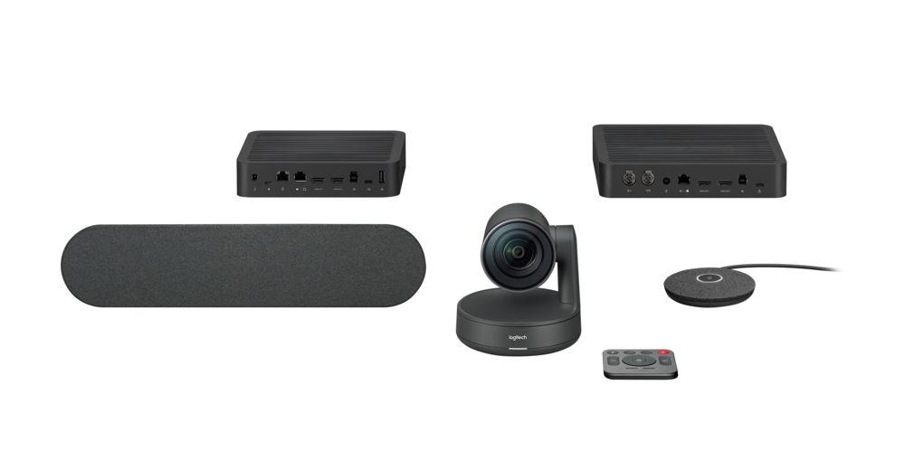

Announcement Date: June 6, 2018
Product | Description | Price | Shipping Date
Logitech Rally Camera | Standalone USB camera | $1,299 | June 2018
Logitech Rally System | Conferencecam with modular audio and clean cabling | $1,999 - $2,499 | Fall 2018
Logitech Rally Accessories | Mic Pod  Mic Pod Hub  Speaker  Mounting Kit | $349  $199  $249  $149 | Fall 2018

Product Description
Logitech® Rally is a premium, modular USB-connected Conferencecam that delivers studio-quality video, exceptional audio clarity, and an automated video conferencing experience. Logitech Rally features an Ultra-HD imaging system, modular audio components, expansive PTZ capabilities, and Logitech RightSense™ technologies that automatically frame people, optimize color and luminance for human faces, and improve vocal clarity for better meetings. Logitech Rally’s modular design makes it ideal for any everyday conference rooms as well as boardrooms, classrooms and large meeting spaces.

Key Features
- Modular Audio Components: Unlike many traditional video conferencing systems, Logitech Rally separates the speaker(s) from the microphone(s). By mounting speakers near the display, audio is aligned with video. The voices of those on the screen come from the front of the room, where people intuitively expect to hear them. The modular design enables both high mic sensitivity and loud volume levels, making Logitech Rally an ideal solution for meeting spaces of almost any size and shape.
- Ultra-HD Video: Premium 4K optics and intelligent PTZ features clearly capture every seat in most any room.
- Logitech RightSense Automation: Logitech RightLight™ optimizes light balance and color to prioritize the appearance of faces and render natural-looking skin tones, even in dim or backlit conditions. Logitech RightSound™ improves vocal clarity by suppressing background noise and echo, auto-leveling voices, and focusing on active speakers so that everyone in the meeting can hear and be heard. Logitech RightSight™ camera control, which will be available later this year through a software download, leverages computer vision to automatically frame meeting participants in the room so that users don’t need to manually adjust the camera angle.
- Premium, Universal Design: Logitech Rally’s sleek design and premium materials complement boardrooms, classrooms and custom installations. Elegantly finished in matte black with slate gray metal trim, the Rally Camera can be positioned on a table, mounted on a tripod, or secured to a wall with included hardware. And its nearly-silent PTZ lens movement allows participants to focus on the meeting rather than the technology.

Product Specifications
Please visit www.logitech.com/rally

System Requirements
Windows® 7, Windows 8.1, or Windows 10
Mac® OS X 10.10 or higher
USB port
Internet connection for optional software download

Compatibility
Logitech Rally is designed to work with almost any conferencing service, such as Microsoft Skype for Business, Microsoft Teams, Google Hangouts Meet, Zoom, BlueJeans and more.

Warranty
- 2-year limited hardware warranty in AMR, EMEA and APAC

Press Contact
Leona Daňková
TAKTIQ COMMUNICATIONS s.r.o.
+420 605 228 810
leona.dankova@taktiq.com

