Fact Sheet

Logitech® G560 PC Gaming Speaker
RGB Lighting Sync Driven by Gameplay

Announcement Date: March 15, 2018 Shipping: April 2018
Price: €249 Available at: LogitechG.com

Product Description
The Logitech® G560 PC Gaming Speaker is a gaming speaker system with sound and projected lights synced with the game. Feel the explosive action from 240 Watts Peak power, while DTS:X Positional Audio® gives amazing 3D audio. Powered by advanced Logitech G LIGHTSYNC™ technology, the Logitech G560 synchronizes brilliant RGB lighting and powerful audio in real-time to match your on-screen action across games, music and movies. Go beyond the screen to fill your room for the most immersive gaming experience ever.

Key Features
- LIGHTSYNC: RGB Light + Sound Driven by Games: Experience new levels of intensity while gaming. LIGHTSYNC RGB immerses you into the action with automatic, game-driven lighting effects that react to many popular games. LIGHTSYNC will blast light to match in-game explosions, approaching enemies, damage taken, healing done, new worlds visited and much more.
- Audio Visualizer: RGB Lighting Driven by Music: See your music. Connect via Bluetooth®, 3.5 jack or USB, and the built-in Logitech G560 Audio Visualizer activates to bring your music to life. Low-volume response is a soft breathing effect. High-volume lighting pulses to the beat — rear lights take the bass and fronts take mids and highs. Connect via USB and use Logitech Gaming Software to customize lighting color and effects*.
- 240 Watts Powerful Sound with 2.1 Setup: Feel the explosive action from 240 Watts Peak (120 Watts RMS) power feeding the down-firing subwoofer and two satellite speakers with lightweight, high-strength metallic drivers. Hear every detail as game and sound designers intended from this 2.1 speaker system. And, from a wide range of angles, thanks to the unique driver design delivering a huge soundscape.
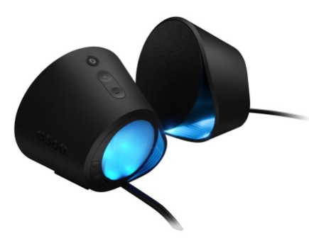
- DTS:X Ultra® Surround Sound: Next-Gen Positional Audio: The intensity you want and the edge you need from precise positional audio. DTS:X Ultra renders a 3D soundscape for games, so you hear your gaming environment from every angle. With DTS:X Ultra, multi-channel music sources such as 5.1 or 7.1 surround become a multi-dimensional experience, as each channel of the mix takes a unique position for heightened realism.
- One Speaker for All Your Audio: Enhance your rig with a versatile, easy-access audio solution. The Logitech G560 connects to and mixes multiple sources: USB, 3.5mm and Bluetooth. A USB connection is required for true digital audio, LIGHTSYNC RGB and DTS:X Ultra surround sound. With Logitech Easy-Switch™, you can seamlessly switch between up to four connected devices.

System Requirements
Works with PC/Mac via:
- USB
- 3.5mm input
- Bluetooth enabled devices, including computers, smartphones and tablets.
Operating Systems:
- Windows® 10, Windows® 8.1 or Windows® 7
- Mac OS X (DTS:X not supported)
- Internet access for Logitech Gaming Software*

Technical Specifications
- Total Watts (Peak): 240
- Total Watts (RMS): 120
- Bluetooth Version: 4.1
- Wireless Range: 25m

Physical Specifications
Speakers
- Height: 5.8''
- Width: 6.5''
- Depth: 4.6''
- Weight: 3.92 pounds (1.79 kg)
Subwoofer
- Height: 15.9''
- Width: 10''
- Depth: 8.1''
- Weight: 12.1 pounds (5.48 kg)

Warranty
- 2-year limited hardware warranty

Press Contact
Leona Daňková
TAKTIQ COMMUNICATIONS s.r.o.
+420 605 228 810
leona.dankova@taktiq.com

*Advanced features require Logitech Gaming Software. Download at LogitechG.com/downloads.

