Fact Sheet

Logitech® G513 Mechanical Gaming Keyboard
Performance evolved.

Announcement Date: March 15, 2018 Shipping: April 2018
Price: €179 Available at: LogitechG.com

Product Description
The ideal keyboard for the gaming enthusiast, the Logitech® G513 Mechanical Gaming Keyboard is an evolution of the Logitech G413 Mechanical Gaming Keyboard, featuring advanced Logitech G LIGHTSYNC™ technology, an intelligent RGB solution that delivers dynamic experience with with custom animations and in-game integrations to perfectly match screen gameplay action.The Logitech G513 also features your choice of Romer-G Tactile or Romer-G Linear switches, as well as an award-winning, streamlined, brushed aluminum design, comfortable palm rest and USB passthrough port. The keyboard is available in Carbon (worldwide) and Silver (Romer -G Tactile only, limited markets).

Key Features
- RGB with LIGHTSYNC Technology for Enhanced Gaming Experiences: Personalize lighting for each individual key, customize animations and experience in-game integrations from across approximately 16.8 million colors using RGB LIGHTSYNC and Logitech Gaming Software**.
- Multiple Switch Choice to Fit Personal Preference: Choose from Romer-G Linear or Romer-G Tactile switches to match your play preferences. The tactile version gives discernible actuation for gamers who prefer direct feedback, while the linear version lets you have a smooth keystroke. Quieter and 25 percent faster than standard mechanical key switches, Romer-G is the superior choice for gamers, as their custom design delivers sharper and brighter lighting, and provides more durability and reliability than competitive switch types.
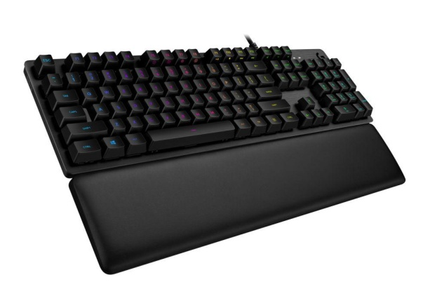
- Long-Lasting Comfort: Built off of the award-winning design of the Logitech G413, the Logitech G513 is designed with an anodized and brushed aircraft-grade 5052 aluminum top case for a slim, premium design with rigid durability. The included palm rest is comprised of memory foam and leatherette for superior comfort, durability, longevity and to be easy to clean. The leatherette on the palm rest is also more environmentally friendly than other palm rests, waterproof, and resistant to abrasions, aging, alcohol and chemicals.
- Integrated USB Passthrough Port: A dedicated USB cable connects the USB 2.0 passthrough port to its own input for 100 percent power throughout. Plug in a third party device or Logitech G mouse to charge up and challenge your adversaries, without missing a moment.

System Requirements
- Windows® 8 or later, Mac OS® X 10.10 or later, Chrome OS™*, Android™* 3.2 or later or iOS 10 or later
- (Optional) Internet access for Logitech Gaming Software**
- USB port for keyboard
- USB port for USB passthrough

Technical Specifications
- Romer-G Switches (Tactile)
  - Feedback Type: Discernable
  - Durability: 70 million key presses
  - Actuation Distance: 1.5mm
  - Actuation Force: 45g
  - Peak Force: 55g
  - Total Travel Distance: 3.0mm
- Romer-G Switches (Linear)
  - Feedback Type: Smooth
  - Durability: 70 million key presses
  - Actuation Distance: 1.5mm
  - Actuation Force: 45g
  - Peak Force: 55g
  - Total Travel Distance: 3.2mm

Physical Specifications
- Length: 5.1” (132mm)
- Width: 17.5” (445mm)
- Height: 1.4” (34mm)
- Weight (w/o cable): 39.0oz (1105g)
- Cable Length: 6 ft

Warranty
- 2-year limited hardware warranty

Press Contact
Leona Daňková
TAKTIQ COMMUNICATIONS s.r.o.
+420 605 228 810
leona.dankova@taktiq.com

*Not supported via Logitech Gaming Software.
**Advanced features require Logitech Gaming Software. Download at LogitechG.com/downloads.

