Fact Sheet

Logitech→ MX ERGO
New trackball offering ultimate comfort and precision tracking.

Announcement Date: Sept. 6, 2017 Shipping: September 2017

Price: $99.99 Available at: www.logitech.com

Product Description
The Logitech→ MX ERGO is a wireless trackball that sets a new standard for comfort and precision. The elegantly designed mouse features an adjustable metal hinge with angles between 0 and 20 degrees for personalized comfort, precision tracking, multi-device connectivity. MX ERGO includes a precision mode button so you can adjust cursor speed and sensitivity with the press of a button. With Logitech Easy-SwitchTM you can connect up to two computers at the same time, and using Logitech FlowTM, MX ERGO allows you easily transfer images and text between them.* A fully charged battery will last for up to four months, and one minute of charging gives you a full day of use, based on typical computing conditions.
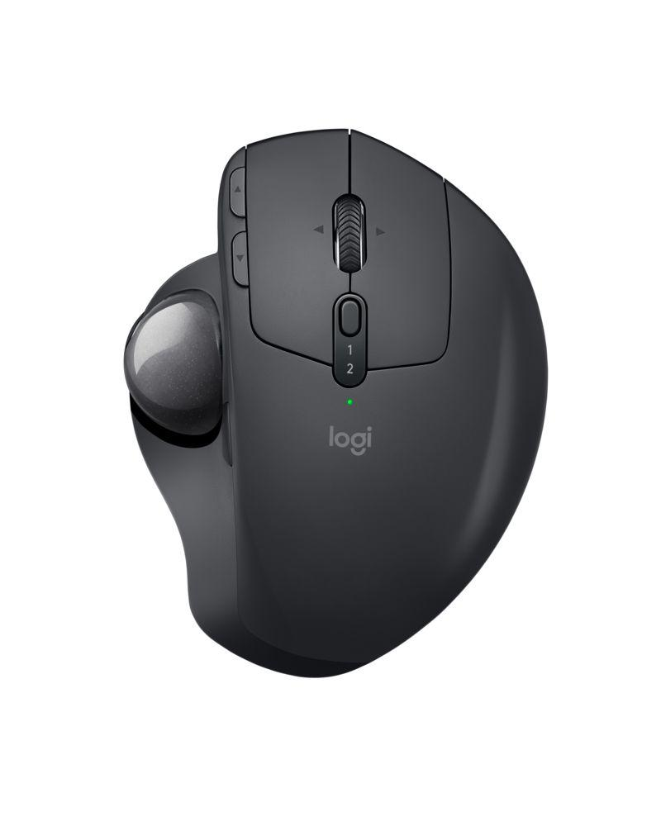
Key Features
- Adjustable metal hinge: With the unique adjustable hinge, you can increase the angle from 0 to 20 degrees that improves the wrist posture and reduces pronation. The carefully sculpted shape gives your hand full palm and finger support, while the soft rubber on the top ensures a good, comfortable grip for long hours of work.
- Precision mode button: Instantly change your cursor speed and accuracy for optimal control with the press of a button. An LED light illuminates when precision is activated.
- Precision scroll wheel with tilt: Use the precision scroll wheel with tilt and middle click for convenient controls and quick access to your favorite shortcuts.
- Easy-Switch and Flow-enabled: Two-channel Easy-Switch capabilities lets you switch between two computers without re-pairing, and you can easily copy/paste text, images and files between them thanks to Logitech Flow technology.
- Rechargeable battery: A fast rechargeable battery holds power for up to four months on a full charge. A quick, one-minute charge gives you a full day of usage.

System Requirements
Unifying Receiver
- Available USB Port
- Windows® 7, Windows 8, Windows 10 or later
- Mac® OS X 10.12 or later
Bluetooth®
- Bluetooth Smart ready
- Windows 8 or higher
- Mac OS X 10.12 or higher

Product Specifications
- Dimensions
- Width: 98 mm
- Height: 47mm
- Depth: 135mm
- Weight: 260g incl. metal hinge

Warranty
- 2-year limited hardware warranty in EMEA
- 1-year limited hardware warranty in AMR, CN and APJ

Press Contact
Wendy Spander
Logitech
wspander@logitech.com
510-713-5393

*Requires Logitech® Options™ software, available for download at www.logitech.com/options.

