Fact Sheet

Logitech® MX Sound Premium Bluetooth® Speakers
A premium audio experience at your desk.

Announcement Date: Aug. 31, 2017 Shipping: end of September 2017
Price: 2 590 Kč Available at: www.logitech.com

Product Description
The Logitech MX Sound is a premium Bluetooth speaker for your desk with exceptional sound in a compact and elegant design. It transforms the desktop audio experience with its high-end drivers and rear-facing port tubes for music, movies and games. Featuring motion-activated backlit controls, MX Sound provides easy volume adjustment and simple Bluetooth device pairing. Listen via Bluetooth or a wired connection and seamlessly switch between them with the Logitech Easy-Switch™ feature to enjoy an immersive experience whether you are streaming from your computer, smartphone or tablet.

Key Features
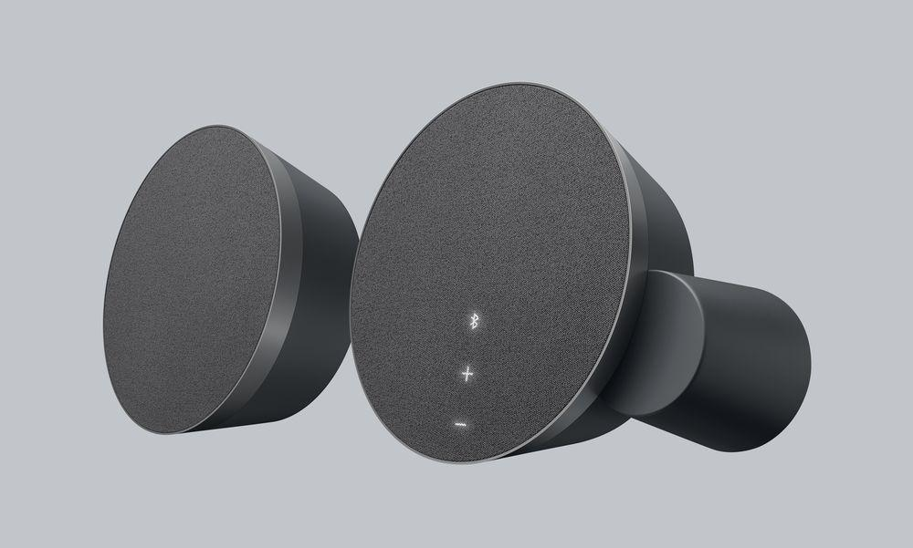
- Versatile setup: Pair up to two Bluetooth devices and/or use a wired connection with Logitech’s Easy-Switch technology to seamlessly switch between audio sources – without pressing any buttons.
- Exceptional sound: Superior drivers and 24 Watt Peak /15 Watt RMS power deliver balanced audio with just enough bass that accurately reproduces the sound the artist intended.
- Intuitive controls: Adjust the volume and pair Bluetooth devices with only a touch to the motion-activated back-lit controls. To conserve power, standby mode automatically activates after 20 minutes of inactivity.
- Compact and elegant design: The MX Sound is elegantly designed, and features silver accent rings, high-end fabric covers and motion-activated, back-lit controls. Plus, these speakers are designed to complement other premium desktop accessories by Logitech, such as the Logitech CRAFT Advanced Keyboard with Creative Input Dial, Logitech Spotlight Presentation Remote and the Logitech MX Master 2S.

Product Specifications
- Product dimensions:
○ Height: 160 mm
○ Width: 160 mm
○ Depth: 83.4 mm
○ Weight (both speakers): 1.72 kg

Technical Specifications
- Total Watts (Peak): 24 W
- Total Watts (RMS): 15 W
- Bluetooth version: 4.1
- 3.5mm input: 2
- Headphone jack: 1

Warranty
- Two-year limited hardware warranty for EMEA

Press Contact
Leona Daňková
TAKTIQ COMMUNICATIONS s.r.o.
+420 605 228 810
leona.dankova@taktiq.com

