Fact Sheet

Logitech® G613 LIGHTSPEED™ Wireless Mechanical Gaming Keyboard
High-performance wireless mechanical gaming keyboard

Announcement Date: Aug. 30, 2017

Shipping: August 2017
Price: €149.00
Available at: gaming.logitech.com

Product Description
The Logitech® G613 Wireless Mechanical Gaming Keyboard is a high-performance wireless keyboard designed for gamers who demand the performance of mechanical switches and the freedom of wireless gaming. The Logitech G613 features both Logitech G’s exclusive LIGHTSPEED™ wireless technology for super fast 1ms report rate and Bluetooth® for multi-host connectivity. It also features Logitech G’s exclusive Romer-G™ mechanical keys and amazing battery life, delivering up to 18 months of gaming on two AA batteries.

Key Features
- LIGHTSPEED Wireless Technology: Featuring a super-fast 1 ms report rate and end-to-end optimized wireless connectivity, the Logitech G613 is more responsive and faster than most wired gaming keyboards. Superior Keystroke Signal Processing allows for extremely fast delivery of every action from the player to the PC.
- Romer-G Key Switches: Logitech’s exclusive Romer-G mechanical switches are purpose-built for professional-grade performance, responsiveness and durability. With a short-throw actuation point of 1.5 mm, Romer-G switches register key presses up to 25 percent faster than standard mechanical switches. Designed to enhance gameplay, Romer-G switches offer the perfect blend of speed, precision and quiet performance.
- Programmable G-Keys: Six programmable G-keys put custom macro sequences and in-app commands at your fingertips. The G-keys can be assigned commands per profile, and have been positioned for optimal speed and accessibility. Connect to Logitech Gaming Software to easily setup and manage profiles and commands.
- Multi-Host: Connect using LIGHTSPEED for super fast 1ms report rate or Bluetooth to control multiple devices. Easily switch between the two with a press of a button.
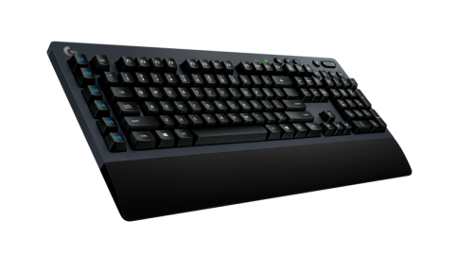

System Requirements
- LIGHTSPEED: USB port and Windows® 7 or later, Mac OS® X 10.8 or later, Chrome OS™, or Android™ 3.2 or later
- Bluetooth®: Bluetooth enabled device with Windows® 8 or later, Mac OS® X 10.10 or later, Chrome OS™, or Android™ 3.2 or later, iOS 10 or later
- Internet access for Logitech Gaming Software¹
- 2x AA batteries (installed)

Technical Specifications
- Romer-G Key Switches
  - Durability: 70 million keypresses
  - Actuation distance: 1.5mm
  - Actuation force: 45g
  - Total travel distance: 3.0mm

- Battery life 18 months ²

- Physical Specs:
  - Length: 478mm
  - Width: 216mm
  - Height: 33.7mm
  - Weight: Keyboard without batteries - 1410g

Warranty
- 2-year limited hardware warranty

Press Contact
Leona Daňková
TAKTIQ COMMUNICATIONS s.r.o.
+420 605 228 810
leona.dankova@taktiq.com

