Fact Sheet

Logitech® G603 LIGHTSPEED™ Wireless Gaming Mouse
Next Generation Gaming Mouse

Announcement Date: Aug. 30, 2017

Shipping: September 2017
Price: €79.99
Available at: gaming.logitech.com

Product Description
The Logitech® G603 LIGHTSPEED™ Wireless Gaming Mouse is a next generation gaming mouse designed for a wireless world. It features Logitech G’s new HERO™ optical sensor, which is capable of achieving high performance with incredible power efficiency. It also features Logitech G’s exclusive LIGHTSPEED™ wireless technology and adjustable performance management.

Key Features
- HERO Sensor: Next-generation HERO (High Efficiency Rated Optical) sensor delivers industry leading performance and up to 10x the power efficiency.* It delivers exceptional accuracy and responsiveness with sensitivity up to 12,000 DPI.
- LIGHTSPEED Wireless Technology: Featuring a 1ms report rate and end-to-end optimized wireless connection, the Logitech G603 delivers incredible responsiveness and reliability for competition-level twitch targeting.
- Performance Management: Switch between HI and LO modes for gaming performance or longer battery life. HI mode delivers peak performance with 1 ms reporting and up to 500 hours of non-stop gaming performance.* When not gaming, easily switch to LO mode to extend battery life. LO mode reports at 8 ms and can extend battery life up to 18 months with two AA batteries.
- Multi-Host: Connect using LIGHTSPEED for the fastest wireless performance and advanced features, or using Bluetooth to pair with multiple devices. Easily switch between the two with a press of a button.
- Comfortable and Energy Efficient: Customize the Logitech G603 to get just the right weight, balance and comfort using either one or two batteries. With two AA Alkaline batteries, the Logitech G603 delivers up to 500 continuous gaming hours, twice as long as the previous generation.
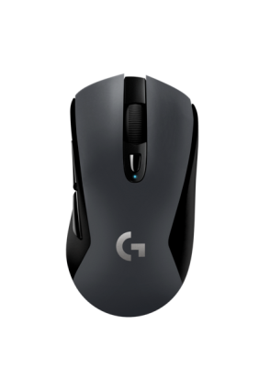
System Requirements
- LIGHTSPEED™: USB port and Windows® 7 or later, Mac OS X 10.8 or later, Chrome OS™, or Android™ 3.2 or later
- Bluetooth®: Bluetooth-enabled device with Windows® 8 or later, Mac OS X 10.12 or later, Chrome OS™, or Android™ 5.0 or later
- Internet access for Logitech Gaming Software²

Physical Specifications:
- Height: 124 mm (4.88 in)
- Width: 68 mm (2.68 in)
- Depth: 43 mm (1.69 in)
- Weight: 88.9 g (3.14 oz), mouse only
- 112.3 g (3.96 oz), with 1 AA battery
- 135.7 g (4.79 oz), with 2 AA batteries
*May vary based on battery discharge characteristics, and user and computing conditions

Tracking
- Sensor: HERO™
- Resolution: 200-12,000 DPI
- Max. acceleration: > 40G³
- Max. speed: > 400 IPS³

Responsiveness
- USB data format: 16 bits/axis
- USB report rate: 1000Hz (1ms)
- Wireless technology: LIGHTSPEED (Logitech G Custom 2.4GHz)
- Microprocessor: 32-bit ARM

Durability
- Main buttons: 20-million clicks with precision mechanical button tensioning
- Feet: > 250-km range³

Battery Life
- HI mode: 500 hours (non-stop gaming)
- LO mode: 18 months (standard usage)

Warranty
- 2-year limited hardware warranty

Press Contact

Leona Daňková
TAKTIQ COMMUNICATIONS s.r.o.
+420 605 228 810
leona.dankova@taktiq.com

