Fact Sheet

Logitech® CRAFT Advanced Keyboard with Creative Input Dial
Flagship Computer Keyboard Gives Immediate Access to App-Specific Functions, Improving Creativity and Productivity with a Computer

Announcement Date: Aug. 31, 2017 Available: mid-September 2017
Price: 5 190 Available at: www.logitech.com

Product Description
The Logitech® CRAFT Advanced Keyboard with creative input dial is a versatile keyboard that offers complete creative control at your desk. Type with confidence on a keyboard crafted for efficiency, stability and precision. Backlit keys light up the moment your hands approach, and automatically adjust to suit changing lighting conditions. The creative input dial revolutionizes your workflow by giving you instant access to the tools you need while adapting to the app you’re using. It allows you to stay completely focused on your work, boosting your productivity and creativity. Install custom profiles in Logitech OptionsTM* to maximize your creative process when working with Adobe Photoshop® CC, Illustrator® CC, Premiere® Pro CC, InDesign CC and Microsoft PowerPoint®, Excel® and Word®.

Key Features
- Unique Creative Input Dial: A touch-sensitive aluminum dial called the Crown recognizes the app you are working in and gives instant control of the tools you need. Slightly touch the crown to instantly access context-specific functions -- like brush size, brightness, chart type, font size --, tap to change the function and turn to change the selected function’s value.This new creative input dial brings comfort, immediacy and convenience to your creative process and allows for increased two-handed interactions. Install profiles from Logitech Options to enhance your creative process when working with Adobe Photoshop CC, Adobe Illustrator CC, Adobe Premiere Pro CC, Adobe InDesign CC, and Microsoft PowerPoint, Excel, and Word.**
- Premium Typing: Type with confidence and precision on a keyboard made of premium materials and crafted for efficiency, stability and precision. Your fingers glide effortlessly between the matte surface of the keys, and the large strike area and spherical dishing mean you can touch type with speed and precision.
- Smart Illumination: Backlit keys light up the moment your hands approach the keyboard and automatically adjust in changing lighting conditions.
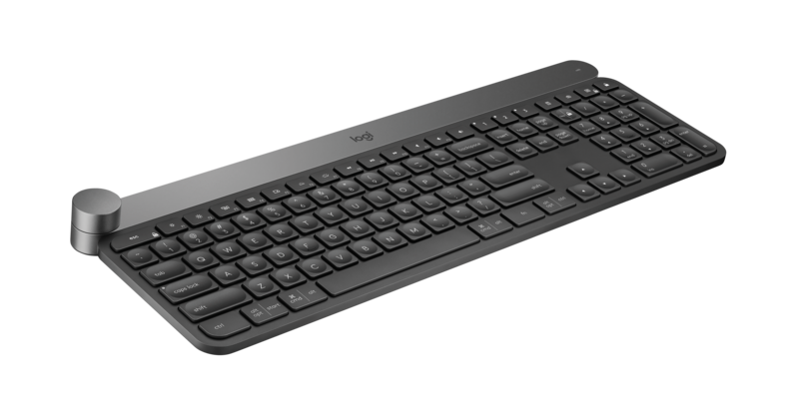
- Intuitive Two-Hand Navigation: Work more efficiently by using intuitive controls that fit into the way you work and create - rather than using shortcuts and unnatural movements. Use the Crown to adjust your work, the keys to type, and a mouse to navigate for a balanced and natural experience.
- Multi-Device and Multi-OS: Pair your keyboard with up to three devices and use Logitech Easy-Switch™ technology to type on – and switch between – any device at the touch of a button. Logitech CRAFT’s dual layout is designed for both Mac and Windows users and optimized to work efficiently on each operating system.
- Dual Connectivity: Connect using a Logitech Unifying receiver or through Bluetooth Low Energy technology.

Product Specifications
- Product dimensions:
  - Height: 32.1 mm (Crown end); 9.90 mm (Keyboard end)
  - Width: 430.3 mm
  - Depth: 148.8 mm
  - Weight: 960 g

Warranty
- 2-year limited hardware warranty for EMEA

Press Contact
Leona Daňková
TAKTIQ COMMUNICATIONS s.r.o.
+420 605 228 810
leona.dankova@taktiq.com

* Requires Logitech Options on Mac OS 10.11 and above and Windows 7 and above. Available for download at logitech.com/options.
** Adobe Creative Cloud 2017 and above - Windows and Mac
** Microsoft Word, Powerpoint, Excel 2010, 2013 and 2016 - Windows only

