Fact Sheet

Logitech Circle 2 Home Security Camera
Security made simple.

Announcement Date: June 14, 2017 Shipping: July 2017
Price: Wired - €199; Available at: www.logitech.com
Wire-Free - €229;
Additional Mounts and Accessories - €29.99 - €59.99

Product Description
The Logitech Circle 2 is the simplest, yet most versatile indoor/outdoor security camera that can be placed anywhere you want. Just put Circle 2 indoors or outside, connect it with the Logi Circle app (iOS/Android or Web), and let the camera do the rest! Taking it a step further, Circle 2 can be combined with different mounts and accessories to extend your home security experience to new places and with the latest smart home integrations such as Apple HomeKit (coming soon), Amazon Alexa and Logitech’s own POP Smart Button, you can easily control your Circle 2. Features such as 1080p HD Video with 2-Way Talk & Listen let you instantly connect with the people and places you love most, no matter where you are. To look back on what’s happened, Smart Alerts and Advanced Event Filtering technology help identify important moments, while Day Briefs™ daily summaries give a full day’s highlights in just 30 seconds.

Key Features
- Versatile Design: Circle 2 can be used as an indoor and outdoor camera, Wired or Wire-Free. With additional mounts and accessories, Circle 2 can go in any place you want:
  - Circle 2 Window Mount - The Window Mount lets you see more of what's happening outside, from the inside. Simply attach the Window Mount to the camera and attach it to any window to see outdoors.
  - Circle 2 Plug Mount - The Plug Mount lets you watch over the home from any wall outlet – in the kitchen, garage, or even down low to see your pet.
  - Circle 2 Weatherproof Extension - The Weatherproof Extension lets your Circle 2 Wired Camera reach even further, both indoors and outdoors. Its Weatherproof Case ensures your cables are safe from outside weather conditions.
  - Circle 2 Rechargeable Battery - A backup Rechargeable Battery (lasts up to 3 months) so you can quickly swap out the Circle 2 Wire-Free Camera battery while the other is charging.
- Best-in-Class Features: Circle 2 offers best-in-class features including unlimited 1080p HD streaming, night vision, 180 degree wide-angle lens, and two-way talk and listen. Every Circle 2 camera also comes with 24-hours of free, secure bank-level encrypted cloud storage.
- Smart Home Integrations: Circle 2 works with today’s most popular smart home platforms. Circle 2 will support Apple HomeKit soon with a software update. Or use Amazon Alexa and the power of your own voice to control key settings and start recordings. Circle 2 also works with Logitech’s own POP Smart Button to easily control your camera with just a press of a button.
- Smart Filtering: Using Advanced Event Filtering and Smart Alerts, see only the interesting and important activities of the day. The Logitech Circle 2 adapts to your home, and filters interesting clips, so you can focus on the activity that matters.
- Custom Daily Summaries: Replay a Day Brief of video highlights in 30 seconds or less, with one tap of the app. And with a Circle Safe subscription, you can edit and customize the length of any video recording, creating your own custom recaps from the past day, week or month. This gives you a new way to save and share your memories.
- Web Portal & Mobile App: Check in, watch Day Briefs and manage settings using the mobile app or the web portal at Circle.logi.com.
- Circle Safe™ Premium Subscription: Starting at €9.99 per month, you can enjoy additional storage and advanced security features, such as Person Detection and Motion Zones to monitor specific areas of home.
- Circle Safe Basic™ Subscription: The Circle Safe Basic Subscription provides 14 days of
- video storage for only €3.99 per month.
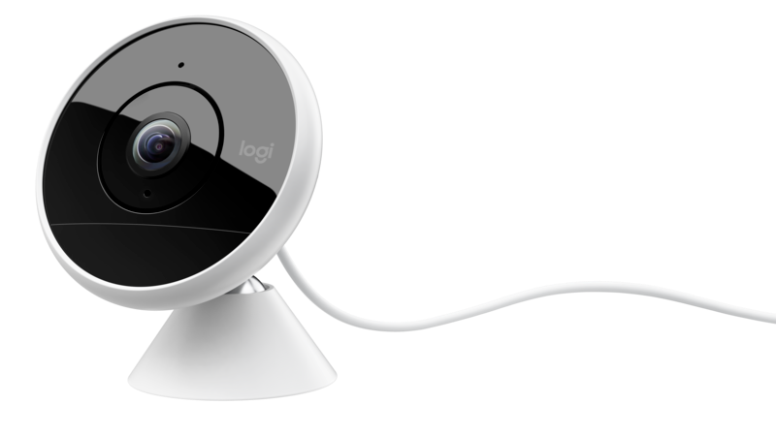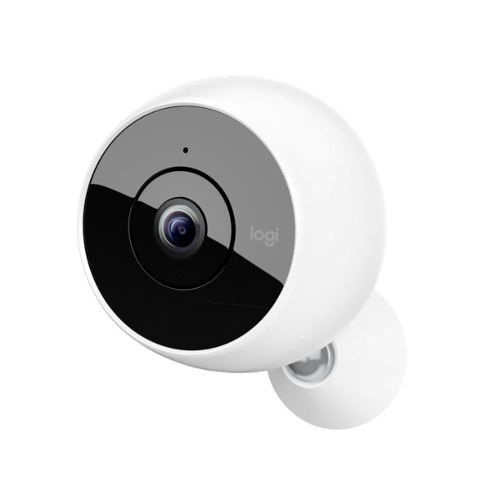
System Requirements
- Bluetooth® wireless
- High-speed Internet connection
- Wireless network

Platform Compatibility
- iOS 8.1 or later with iPhone 4s or later, iPad mini or later, iPad 3 or later, iPod Touch (5th generation) or later
- Android™ 4.4 or newer with Bluetooth® low energy technology

Product Specifications
- Wired Circle 2:
  - Dimensions (L x W x H): 66.7mm x 71mm x 85.5mm
  - Camera weight: 207g
- Wire-Free Circle 2:
  - Dimensions (L x W x H): 94.8mm x 81.6mm x 97.2mm
  - Camera weight: 340g

Warranty
- 2-year limited hardware warranty in EMEA

