eFact Sheet

Logitech→ MX Master 2S Wireless Mouse
The MX Master is made even better with advanced features for multi-computer use.

Announcement Date: June 1, 2017 Shipping: June 2017

Price: €109 Available at: www.logitech.com

Product Description
The Logitech→ MX Master 2S updates the flagship mouse to bring multi-computer use to a bold new level. By harnessing the power of Logitech FLOW, you can control up to three computers and seamlessly move text, images and files between devices. Your hand and wrist is supported with an ergonomic design as you scroll through documents and Web pages faster and easier with a speed-adaptive scroll wheel in a handcrafted, sculpted shape. A quick, rechargeable battery gives you a day’s worth of work in just minutes and can hold a full charge for over two months. And thanks to high precision tracking, you can work virtually anywhere, even on glass.*
Key Features
- Logitech FLOW: Seamlessly control multiple devices at the same time and even copy-paste content and documents between those computers.**
- Darkfield™ High Precision Tracking: Track on almost any surface with flawless control, even glass, with up to 4,000 dots per inch.
- Rechargeable Battery: Plug MX Master 2S into your computer using the micro-USB charging cable and get enough power for a full day of usage in only three minutes with a full charge that can last up to 70 days.***
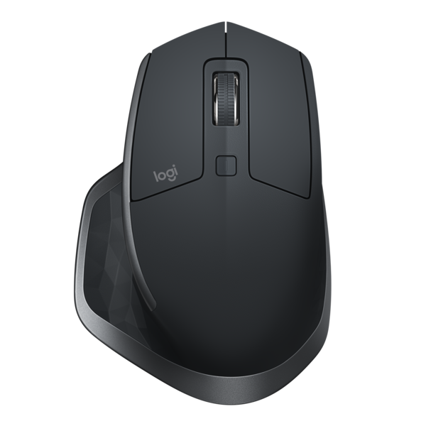
- Unique Scrolling Experience: Scroll through Web pages faster and easier with a speed-adaptive scroll wheel that auto-shifts from click-to-click to hyper-fast scroll.
- Comfortable Shape: Crafted to fit your hand, this comfortable mobile mouse provides the control you need at home, at work or on the go.

System Requirements
Unifying Receiver
- Available USB Port
- Windows® 7, Windows 8, Windows 10 or higher
- Mac® OS X 10.10 or higher
Bluetooth®
- Bluetooth low energy technology
- Windows 8 or higher
- Mac OS X 10.10 or higher

Product Specifications
- Dimensions
- Width: 8.6 cm
- Height: 12.7 cm
- Depth: 3.4 cm
- Weight: 145 g
- Number of buttons: 7
- Sensor technology: Darkfield high precision
- Sensor resolution:
- Nominal Value: 1,000 dpi
- Minimal and Maximal Value: 200 to 4,000 dpi
- Logitech Advanced 2.4 GHz wireless connectivity

Warranty
- 2-year limited hardware warranty in EMEA

Press Contact
Leona Daňková
TAKTIQ COMMUNICATIONS s.r.o.
+420 605 228 810
leona.dankova@taktiq.com

*4mm min thickness
**Requires Logitech® Options™ software, available for download at www.logitech.com/options.
***Battery life may vary based on user and computing conditions.

