Fact Sheet

Logitech→ M590 Multi-Device Silent Mouse
Stay productive in silence with a highly versatile and customizable multi-device wireless mouse

Announcement Date: June 1, 2017 Shipping: June 2017
Price: €49.99 Available at: www.logitech.com

Product Description
With Logitech FLOW, the Logitech M590 Multi-Device Silent Mouse can navigate seamlessly on two computers at the same time and copy-paste from one to the other – even if you're using a PC and a Mac®. The M590 Multi-Device Silent features ultra-precise scrolling, two handy thumb buttons, a 24-month battery and a curved design so you can scroll through long Web pages faster, and use the extra control and comfort to make it simpler to get things done. All the while, these capabilities can be experienced in silence. With the same click feel, enjoy a 90 percent noise reduction in sound so you don’t disturb those around you..
Key Features
- Logitech FLOW: Seamlessly control multiple devices at the same time and even copy-paste content and documents between those computers.*
- Enjoy the Sound of Silence: The mouse provides an over 90 percent noise reduction in click sounds with the same click feel and a rubber wheel for quiet gliding.
- Ultra-Precise Scrolling: A micro-precision scroll wheel packs more grooves per millimeter, making scrolling through long webpages faster and easier.
- Two Thumb Buttons: Two customizable thumb buttons come programmed to move backwards and forwards through Web pages but can be re-programmed to do exactly what you want them to.
- 24-Month Battery Life: This mouse just keeps going, with 24 months of power on a single AA battery.** Automatic sleep mode and an On/Off switch save power, while an indicator light eliminates surprises.

System Requirements
Unifying Receiver
- Available USB Port
- Windows® 10 or later, Windows 8, Windows 7
- Mac OS X 10.10 or higher
- Chrome OS™
- Linux Kernel 2.6+
Bluetooth® Low Energy Technology
- Windows 10 or higher, Windows 8, Windows 7
- Mac OS X 10.10 or higher
- Chrome OS, Android 5.0 or higher

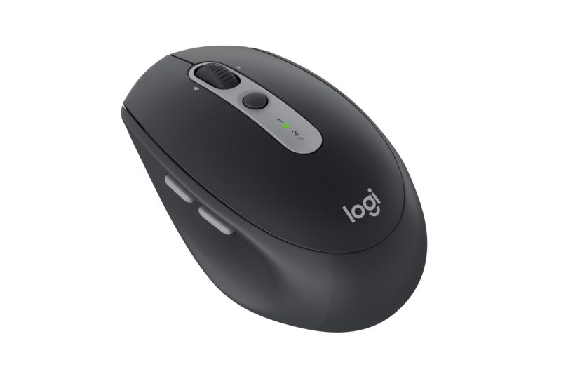
Product Specifications
- Dimensions
- Width: 2.52 in (64 mm)
- Height: 1.57 in (40 mm)
- Depth: 4.05 in (103 mm)
- Weight (including battery): 100 g
- Number of buttons: 7
- Sensor technology: Laser Grade Optical Tracking
- Sensor resolution: 1000 dpi
- Battery type: 1 AA

Warranty
- 2-year limited hardware warranty in EMEA

Press Contact
Leona Daňková
TAKTIQ COMMUNICATIONS s.r.o.
+420 605 228 810
leona.dankova@taktiq.com

*Requires Logitech® Options™ software, available for download at www.logitech.com/options.
**Battery life may vary based on user and computing conditions.

