Fact Sheet

Logitech® G903 LIGHTSPEED™ Wireless Gaming Mouse
The ultimate wireless gaming mouse, trusted by eSports professionals and gaming enthusiasts worldwide

Announcement Date: June 12, 2017 Shipping: June 2017
Price: 179.00€ Available at: www.LogitechG.com

Product Description
The Logitech® G903 LIGHTSPEED™ Wireless Gaming Mouse is the ultimate wireless gaming mouse. Trusted by esports pros and gaming enthusiasts worldwide, it features LIGHTSPEED™ wireless technology, a pixel-precise optical gaming sensor, advanced mechanical button tensioning, and a lightweight, customizable design, for maximum performance and comfort over long gameplay sessions. The Logitech G903 is also compatible with the POWERPLAY™ Wireless Charging System, for untethered play, unlimited charging, and unmatched performance.

Key Features
- LIGHTSPEED Wireless Technology: In high-pressure moments, latency can be the difference between winning it all or losing. With millions on the line, esports professionals around the world depend on LIGHTSPEED wireless technology. Featuring a 1 ms report rate and end-to-end optimized wireless connectivity, the Logitech G903 delivers incredible responsiveness for competition-level twitch targeting.
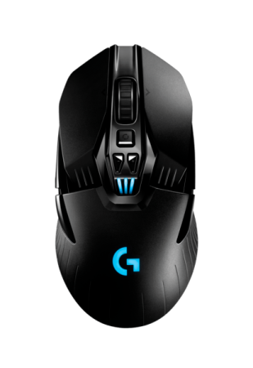
- POWERPLAY Wireless Charging System Compatibility: The Logitech G903 is compatible with the POWERPLAY Wireless Charging System, the world’s first truly wireless gaming solution that delivers infinite power and unlimited play. Through the innovative application of electromagnetic resonance, the POWERPLAY base creates an energy field above its surface. Unlike conventional wireless charging technologies, this field is large enough to allows charging even while the compatible wireless gaming mouse is in motion. And, it delivers this wireless power without interfering with the precise measurement and data transmission of a high-performance gaming mouse. The POWERPLAY energy field is transformed into charging current by the POWERCORE™ module, which attaches magnetically to the Logitech G903.
- Pixel-Precise Sensor: The PMW3366 is widely regarded by esports professionals and gaming enthusiasts as the best gaming mouse sensor on the market. Thanks to years upon years of innovations, PMW3366 has zero smoothing, filtering, or acceleration across the entire DPI range (200-12,000 DPI). The resulting experience is incredible tracking accuracy and consistent responsiveness even at speeds over 400 IPS.
- Advanced Pivot Key Design with Mechanical Button Tensioning: Precisely-tensioned metal springs and exclusive mechanical pivot hinges keep the primary left and right mouse buttons poised to trigger. This technology delivers an exceptionally clean and crisp button feel, response, and consistency. Logitech G improved on the design and boosted button durability up to 2.5x with 50 million click switches.
- Comfortable and Customizable: Designed to be ultra-lightweight and customizable, every component of Logitech G903 has been optimized to reduce weight while maintaining stability. Each element of the construction was analyzed and adjusted to remove milligrams to create a wireless mouse that weighs only 110g. A configurable button layout and ambidextrous design allows for left- or right-handed use that works with nearly any mouse grip style, including palm, claw and fingertip grips. Program 6-11 buttons with custom game commands using Logitech Gaming Software (LGS).

System Requirements
- Windows® 7 or higher, Mac OS® X 10.8 or later
- USB port
- Internet connection for optional software download

Physical Specifications
- Dimensions (L x W x D): 130 mm x 67 mm x 40 mm
- Weight: 110g
- Cable length (charging/data): 1.83 m (6 ft)

Tracking
- Resolution: 200 – 12,000 DPI
- Maximum acceleration: >40G*
- Maximum speed: >400 IPS*

Responsiveness
- USB data format: 16 bits/axis
- USB report rate: 1000Hz (1ms)
- Wireless technology: LIGHTSPEED (Logitech G Custom 2.4GHz)
- Microprocessor: 32-bit ARM

Durability
- Main buttons (Left / Right): 50 million clicks
- Max. distance: >250 kilometers*

Battery Life
- Default lighting: 24 hours**
- No lighting: 32 hours**

* Tested on Logitech G240 Gaming Mouse Pad
** Rechargeable batteries have a finite number of charge cycles

Warranty
- 2-year limited hardware warranty

Press Contact
Leona Daňková
TAKTIQ COMMUNICATIONS s.r.o.
+420 605 228 810
leona.dankova@taktiq.com

