Fact Sheet

Logitech® POWERPLAY™ Wireless Charging System
Infinite Power. Unlimited Play.

Announcement Date: June 12, 2017 Shipping: August 2017
Price: 129.00€ Available at: www.LogitechG.com

Product Description
The Logitech® POWERPLAY™ Wireless Charging System is the world’s first wireless gaming mouse charging system. Now, you can experience endless wireless gameplay at the highest levels possible. With POWERPLAY and LIGHTSPEED™ technology, Logitech G has solved the barriers to high performance wireless gaming. Input lag, wireless disconnects, and dead batteries are now a thing of the past.

Key Features
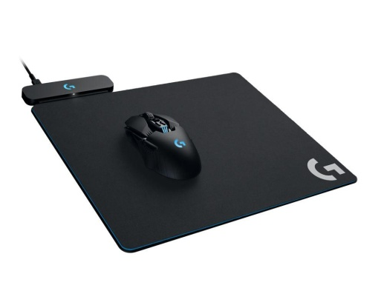
- POWERPLAY™ Charging Technology: Through the innovative application of electromagnetic resonance technology, the POWERPLAY base creates an energy field above its surface. Unlike conventional wireless charging technologies, this field is large enough that POWERPLAY allows charging even while a compatible gaming mouse is in motion. And, it delivers this power without interfering with the precise measurement and data transmission of a high-performance gaming mouse. Integrating all the technology of POWERPLAY into a 2mm thin form factor was no simple task.
- POWERCORE™ Module: The POWERPLAY energy field is transformed into charging current by the POWERCORE module, which attaches magnetically to compatible wireless gaming mice. The beauty of POWERPLAY is that your mouse will charge while at play and at rest.
- LIGHTSPEED™ Wireless Technology Built-In: Logitech G invented LIGHTSPEED wireless technology to deliver the ultimate in high-performance wireless gaming. LIGHTSPEED wireless technology is as fast or faster than competitive wired gaming mice, so you get the freedom of wireless with no compromises.
- Cloth and Hard Gaming Mouse Pads Included: Tune your performance to your mouse pad of choice. The system includes both cloth and hard surfaces so you can play the way you want to. POWERPLAY will suit your style right out of the box.
- POWERPLAY Wireless Gaming Mice: The included POWERCORE module enables POWERPLAY wireless charging with compatible wireless mice. It works with the all-new Logitech G903 and G703 mice. Easily swap in the magnetic POWERCORE module and you’re ready to wirelessly charge.

System Requirements
- Windows® 7 or higher
- Powered USB port
- Internet connection for optional software download

Physical Specifications
- Length: 275 mm
- Width: 320 mm
- Control module height: 10 mm
- Charging surface thickness: 2 mm
- Cloth Mouse Pad thickness: 2 mm
- Hard Mouse Pad thickness: 3 mm
- Cable Length: 1.8m (6 ft)

Warranty
- 2-year limited hardware warranty

Press Contact
Leona Daňková
TAKTIQ COMMUNICATIONS s.r.o.
+420 605 228 810
leona.dankova@taktiq.com

