Fact Sheet

Logitech® G433 7.1 Gaming Headset
Advanced gaming audio designed to play whenever you do.

Announcement Date: June 8, 2017 Shipping: June 2017
Price: 3 569 Kč Available at: www.LogitechG.com

Product Description
The Logitech G433 7.1 Gaming Headset featured advanced audio technologies such as Pro-G drivers and DTS Headphone:X®, in a comfortable, lightweight, and stylish design. The G433 features high-grade audio in a modern headset that is suitable for use everywhere in a gamer’s life, and comes in four custom colours, Royal Blue, Fire Red, Triple Black and Camo Blue.

Key Features
- Comfortable and Stylish Design: The Logitech G433 is lightweight and extremely comfortable. The Logitech G433 weighs in at 259 grams and is one of the lightest headset Logitech designed to date. It features a hydrophobic, stain-resistant fabric finish that comes in four vibrant colours: Royal Blue, Fire Red, Triple Black, and a special Camo Blue, sold exclusively through Best Buy. The headset features breathable sports mesh ear pads that can be easily removed and are hand-washable. It also comes with a second set of lush microfiber ear pads for a different fit and feel.
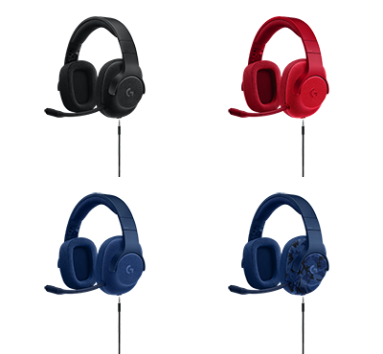
- High-Quality Audio: The Logitech G433 features advanced Pro-G drivers made with hybrid mesh materials that provide high-quality audio. Logitech G optimized the sound quality for both analog reproduction and digital USB output, so the sound profile is accurate on any source. With the USB sound card and DTS Headphone:X, G433 can accurately replicates 7.1 speaker placement and audio positioning, so you can hear in-game environmental effects and positional audio that game designers intend you to hear, such as how far away enemies are and which direction they are coming from. With the Logitech Gaming Software you can tune the volume levels for each of the seven audio channels.
- Extremely Clear Communication: The Logitech G433 includes a removable, high-quality boom microphone with a micro pop filter for high quality voice chat. G433 is officially Discord Certified — guaranteeing the highest levels of audio and voice clarity. Multi-Platform Support: The headset supports PCs, consoles (including Xbox One, PlayStation®4, and Nintendo Switch™) and mobile devices.

System Requirements
- Analog 3.5mm audio sources (mobile / console / sound cards) or USB port (G433 only)
- DTS Headphone:X and fine-tuned settings require Logitech Gaming Software
- Logitech Gaming Software requires Windows® 7 or higher
- Internet connection for Logitech Gaming Software download and installation

Technical Specifications
Headphone:
Driver: 40 mm
Frequency response:20Hz–20KHz
Impedance: 32 Ohms
Sensitivity: 107dB@1KHz SPL
30mW/1 cm

Microphone:
Microphone Pickup Pattern:Cardioid (Unidirectional)
Type: Back Electret

Condenser Size: 4 mm
Frequency response:100Hz–10KHz
Length: 172 mm (6.77 in)
Width: 81.7 mm (3.22 in)
Height: 182 mm (7.17 in)
Weight (w/o cable): 259 g
(9.14 oz)

PC Cable Length: 6.56 ft
Mobile Cable Length: 4.92 ft

Warranty
- 2-year limited hardware warranty

Press Contact
Leona Daňková
TAKTIQ COMMUNICATIONS s.r.o.
+420 605 228 810
leona.dankova@taktiq.com

