Fact Sheet

Logitech® G233 Prodigy Gaming Headset
High-grade audio in a comfortable and lightweight design

Announcement Date: June 8, 2017 Shipping: June 2017
Price: 2 499 Kč Available at: www.LogitechG.com

Product Description
The Logitech® G233 Prodigy Gaming Headset is a lightweight, comfortable headset that features a soft-touch finish and delivers robust sounds. It features advanced audio technologies such as Pro-G™ audio drivers, and works with multitude of devices so you can play wherever, whenever.

Key Features
- Comfortable and Lightweight Design: The Logitech G233 weighs in at 259 grams and is one of the lightest headset Logitech designed to date. The headset features breathable sports mesh ear pads that can be easily removed and are hand-washable.
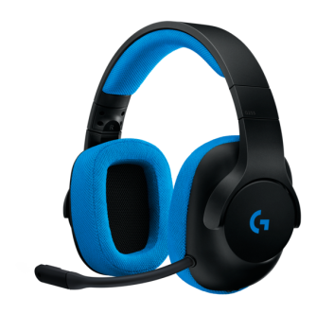
- High-Quality Audio: The Logitech G233 features advanced Pro-G audio drivers made with hybrid mesh materials that provide audiophile-like performance. Logitech G optimized the sound quality for analog reproduction so the sound profile is accurate on any source. The drivers deliver clear highs and mids with incredible imaging, with a warm deep bass.
- Extremely Clear Communication: The Logitech G233 includes a removable, high-quality boom microphone with micro-pop filter for crystal-clear voice chat and communications. The Logitech G433 includes a removable, high-quality boom microphone with a micro pop filter for high quality voice chat. G233 is officially Discord Certified — guaranteeing the highest levels of audio and voice clarity.
- Multi-Platform Support: The headset supports PCs, consoles (including Xbox One, PlayStation®4, and Nintendo Switch™) and mobile devices.

System Requirements
- 3.5 mm mic/audio port or Dual Microphone and Headphone 3.5 mm ports
Technical Specifications

Headphone:
Driver: 40 mm
Frequency response:20Hz–20KHz
Impedance: 32 Ohms
Sensitivity: 107dB@1KHz SPL
30mW/1 cm

Microphone:
Microphone Pickup Pattern:Cardioid (Unidirectional)
Type: Back Electret

Condenser Size: 4 mm
Frequency response:100Hz–10KHz
Length: 172 mm (6.77 in)
Width: 81.7 mm (3.22 in)
Height: 182 mm (7.17 in)
Weight (w/o cable): 259 g
(9.14 oz)

PC Cable Length: 6.56 ft
Mobile Cable Length: 4.92 ft

Warranty
- 2-year limited hardware warranty

Press Contact
Leona Daňková
TAKTIQ COMMUNICATIONS s.r.o.
+420 605 228 810
leona.dankova@taktiq.com

