Fact Sheet

Logitech® G413 Mechanical Gaming Keyboard
Pure Performance and Modern Design.

Announcement Date: April 19, 2017 Shipping: April 2017
Price: €99.99 Available at: www.LogitechG.com

Product Description
The Logitech® G413 Mechanical Gaming Keyboard delivers unrivaled performance in a thoughtfully balanced, modern design. It features Logitech’s exclusive Romer-G™ mechanical switches, offering 25 percent faster actuation than standard mechanical switches, as well as a lightweight aluminum body, USB passthrough port and precision key backlighting. There is also the Logitech G413 Silver Mechanical Backlit Gaming Keyboard, sold exclusively at Best Buy.

Key Features
- Romer-G Mechanical Switches: Logitech’s exclusive Romer-G mechanical switches are purpose-built for professional-grade performance, responsiveness and durability. With a short-throw actuation point of 1.5 mm, Romer-G switches register key presses up to 25 percent faster than standard mechanical switches, so you can get your shots off faster than your opponent. Designed to enhance gameplay, Romer-G switches offer the perfect blend of speed, precision and quiet performance.
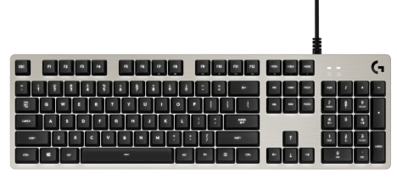
- Precision Key Lighting: Romer-G mechanical switches are also purpose-designed for precise and clean lighting through the keycaps. This means keys are always visible and never distracting, especially during late night gaming sessions. The Logitech G413 Carbon features elemental red backlighting and the Logitech G413 Silver features iconic white backlighting, for a premium, focused look.
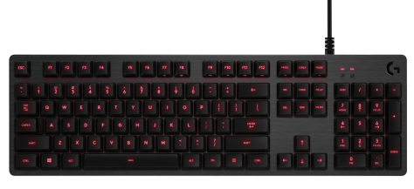
- Aircraft-Grade Aluminum Alloy: A brushed 5052 aluminum-magnesium alloy top case serves as the keyboard’s backbone. The result is a minimal design balanced with a full set of features. With a focus on high-end finish and performance, the Logitech G413 is crafted from the highest-grade materials.
- USB Passthrough: Convenience and speed are directly within reach. The additional, dedicated USB cable connects the USB passthrough port to its own input for full power throughput and data speed.
- Full Function Keys: Media control is built-in so you can use the FN key to control volume, play and pause, mute, game mode, lighting, etc. The FN toggle feature in the Logitech Gaming Software (LGS) configure the keys to perform media commands by default.
- Programmable Macros: Use LGS to program custom functions and macro commands on F1-F12 buttons. Execute complex commands, or unleash a timed series of actions or spells with the press of a button.
- Performance Keycaps: Laser-etched cylindrical keycaps come standard plus a set of 12 optional performance faceted keycaps designed by esports pros are included.

System Requirements
- Windows® 7 or higher
- Internet connection for Logitech Gaming Software installation
- USB port for keyboard
- USB port for USB passthrough

Technical Specifications
- Romer-G Switches
  - Durability: 70 million key presses
  - Actuation distance: 1.5mm
  - Actuation force: 45g
  - Total travel distance: 3.0mm
- Physical Specifications:
  - Dimensions (L x W x D): 132mm x 445mm x 34mm
  - Weight (without cable): 1105g
  - Cable length: 6 feet

Warranty
- 2-year limited hardware warranty

Press Contact
Leona Daňková
TAKTIQ COMMUNICATIONS s.r.o.
+420 605 228 810
leona.dankova@taktiq.com

