FACT SHEET

Ultimate Ears WONDERBOOMTM
The pint-sized, portable speaker with huge personality and surprisingly big sound.

Announcement Date: March 29, 2017 Shipping: April 2017
Price: 2 699 Kč Available at: www.ultimateears.com

Product Description
Enjoy your music the way it is meant to be heard with Ultimate Ears WONDERBOOM, the super-portable, waterproof, BluetoothⓇ speaker with surprisingly big sound. WONDERBOOM blasts 360-degree sound that is clear, crisp and full of big, beautiful bass. Waterproof and worry-proof, WONDERBOOM floats on its own and sports a hanging loop on top. This little beauty is also a beast. It is drop-proof from up to five feet, boasts a 10-hour battery life and 100-foot wireless Bluetooth range*. To turn things up, connect two WONDERBOOM speakers together to party louder.
Key Features
- Surprisingly Big Sound: WONDERBOOM is a pint-sized, portable speaker that blasts clear, crisp, non-stop 360-degree sound with big, beautiful bass.

- Seriously Waterproof: IPX7 rated (it can be immersed in water up to one meter for up to 30 minutes) and able to float on its own, WONDERBOOM is the perfect companion for showers, pools, beaches, muddy fields and rainy days. If WONDERBOOM gets dirty, just rinse it off.

- 10 Hours of Happiness: WONDERBOOM is there all day, all night - from picnics in the park to poolside parties - with up to 10 hours of battery life*.

- Double the Speakers, Double the Fun: If you think one WONDERBOOM sounds great, you'll love how they sound together. Connect two WONDERBOOM speakers together to turn things up.

- No Fuss, No Friction, Just Music: Power on, pair it, press play. Want more? The UE button on the top of the speaker lets you play, pause and skip your music.

System Requirements
- Smartphone, tablet or other devices that support Bluetooth wireless audio profile (A2DP)

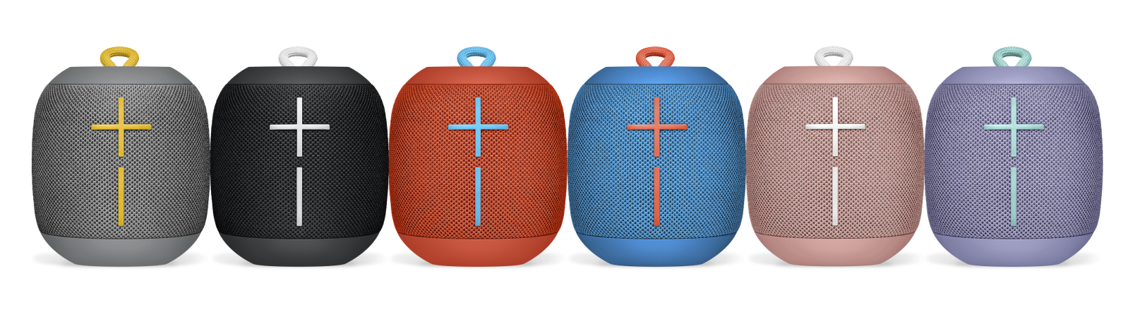
Product Specifications
- Height: 102mm
- Diameter: 93.5mm
- Weight: 15 oz

Warranty
- Two-year limited hardware warranty

Press Contact
Leona Daňková
TAKTIQ COMMUNICATIONS s.r.o.
+420 605 228 810
leona.dankova@taktiq.com

*Actual wireless range and battery life will vary with use, settings and environmental conditions.

