Fact Sheet

Logi BASE
Charging stand with Smart Connector technology for iPad Pro

Announcement date: April 26, 2016 Shipping: April 2016
Price: 2 790 Kč Available at: www.logitech.com

Product Description
Logi BASE Charging Stand with Smart Connector™ is the charging stand that belongs with your iPad Pro™. Designed in collaboration with Apple, Logi BASE leverages the Smart Connector to provide an effortless drop-and-go charging solution for your iPad Pro. BASE also provides the perfect viewing angle when your iPad is on a desk, countertop or nightstand. Made from high-quality aluminium materials and with a sturdy anti-slip pad, Logi BASE takes charging to a whole new level.

Key Features
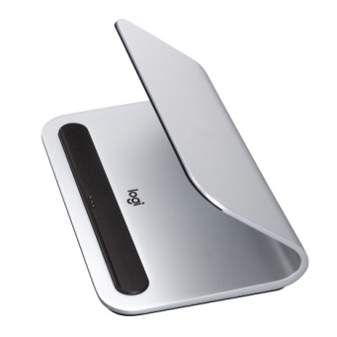
- Apple Smart Connector compatibility: Logi BASE charges your iPad through the Smart Connector. Magnets in the charging cradle guide your iPad Pro into place to align with the Smart Connector. Just drop your iPad Pro on BASE and it begins to charge.
- New possibilities in every room: Logi BASE is the best place for your iPad Pro to be in every room of the house. You can prop up and charge your iPad Pro at the perfect angle while taking full advantage of your tablet, with over a million apps to choose from and the intelligence of Siri®, you can completely rethink the way you use your iPad Pro.
- Designed for iPad Pro: From the high-grade aluminium to the premium finish and curved shape, every detail is designed to complement the iPad Pro, and makes it a pleasure to look at and use.

System Requirements
- 12.9-inch iPad Pro or 9.7-inch iPad Pro

Product Specifications
- Dimensions (H x W x D): 3.23 in x 7 in x 4.48 in
- Weight: 12.6 oz
- MFi Certified: Passes rigorous testing with Apple to work perfectly with the iPad Pro

Warranty
- 2-year limited hardware warranty in EMEA

Contact
Leona Daňková
TAKTIQ COMMUNICATIONS s.r.o.
+420 605 228 810
leona.dankova@taktiq.com

