

Fact Sheet

Logitech® G633 Artemis Spectrum Gaming Headset
Gaming headphones for serious audio fans.

Announcement Date: Aug. 27, 2015 Shipping: October 2015
Price: 4 690 Kč Available at: gaming.logitech.com

Product Description
Experience your gaming and audio like never before with the Logitech® G633 Artemis Spectrum™ Gaming Headset. Compatible with PC, consoles, mobile devices and home theater devices, the Logitech G633 features patent pending Pro-G™ audio drivers and were designed by Logitech’s sound engineering team, with more than 25 years in audio development. With 7.1 Dolby® Surround Sound and DTS Headphone:X*, these headphones deliver a superior all-around audio experience. The G633 is customizable, featuring RGB lighting, swappable backlit speaker plates, programmable G-keys and an onboard software equalizer to customize audio settings and create personal sound profiles.

Key Features
- Superior All-Around Audio: From your favorite music to expansive game soundtracks, the patent pending Pro-G audio drivers deliver both clean and accurate highs as well as a deep rich bass that you would expect from premium headphones. These are also the first headphones to offer both Dolby and DTS Headphone:X* surround options to gamers. The Pro-G audio drivers and surround sound technologies create lifelike in-game spatial awareness, allowing you to clearly hear enemies sneaking around, or special ability cues. DTS Headphone:X* technology utilizes calibration and processing that brings gamers and audio fans closer to the studio experience than ever before, supporting up to 11.1 channels of audio and multiple options for personalization.
- Multi-Platform Support and Sound Mixing: The Logitech G633 works with PCs, mobile devices and consoles – including PlayStation® 4 and Xbox One™– and features one USB mix connection and one analog input that connects and mixes sound from up to two devices. As you are fending off your gaming enemies from your PC, you can simultaneously order a pizza on your cell phone without missing a moment of action.
- Personalized Programmability and RGB Lighting: Use Logitech Gaming Software to program lighting, audio and buttons. Adjust RGB lighting from up to 16.8 million colors and assign custom game macros on three programmable G-keys for a seamless gaming experience. A software equalizer lets you customize audio settings and create personal sound profiles so you can listen to music, games and movies with preset audio preferences.
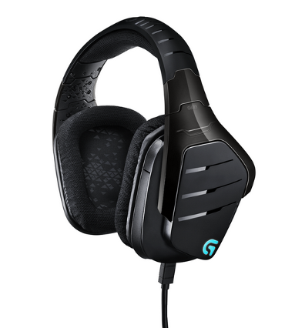
- Foldaway, Noise-Cancelling Mic: The Logitech G633 features a crystal-clear noise-cancelling boom mic. An indicator LED lets you know when your microphone is on mute. When not in use, the mic can be folded back into the headset.

System Requirements
- Windows® 7 or higher
- Internet connection for Logitech Gaming Software installation
- USB port or 3.5 mm audio port
- 7.1 surround sound, DTS Headphone X*, lighting configuration, and G-key programming require Logitech Gaming Software

Product Specifications
- Headphones
  - Driver: 40 mm
  - Frequency response: 20Hz-20KHz
  - Impedance: 32 Ohms
  - Size: 190 mm x 180 mm x 94 mm
  - Weight : 374 grams (13.19 oz)
- Microphone
  - Size: 4 mm
  - Type: Consenser-Cardioid
  - Frequency response: 100Hz-20KHz
  - Sensitivity: 107dB SPL/Mw

Warranty
- 2-year limited hardware warranty

*DTS Headphone:X support will be available through a Logitech Gaming Software update in early Oct. 2015

Press Contact
Leona Daňková
TAKTIQ COMMUNICATIONS s.r.o.
+420 605 228 810
leona.dankova@taktiq.com

