Fact Sheet

Logitech® AnyAngleTM
The case that adjusts so you don’t have to.

Announcement Date: Nov. 19, 2014 Shipping: November 2014
Price: 1 659 Kč Available at: www.logitech.com

Product Description
The Logitech® AnyAngle™ is a protective case for your iPad Air 2 and all models of the iPad mini that firmly holds your iPad at any angle within a 50-degree viewing range. It has an adjustable any-angle stand that uses a hidden hinge and magnetic system, so you keep a comfortable viewing angle, no matter what you do. Plus, the Logitech AnyAngle comes in a variety of color combinations, designed to suit your style. So whether you prefer a sophisticated, classic black or want to make a statement with violet or teal, we have your unique look covered.

Key Features
- Any-angle stand: The case’s any-angle stand uses a hidden hinge that holds your iPad at any angle within a 50-degree range, and firmly keeps that angle in place without tipping or sliding. The any-angle stands folds entirely behind the iPad, so you get a clean, minimalist experience in stand mode or during hand-held use.
- Essential Protection System: The case’s Essential Protection System protects your iPad from accidental bumps, scratches and spills. The Logitech AnyAngle is precision engineered with durable and water-repellent materials that protect the front and back of the iPad, without added weight or bulk.

System Requirements
- iPad Air 2
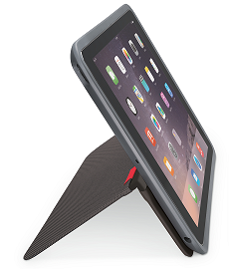
- iPad mini, iPad mini with Retina Display, iPad mini 3

Product Specifications for iPad 2
- Dimensions (L x W x H): 252.8 mm x 183.8 mm x 14.3 mm
- Weight: 342g

Product Specifications for all iPad mini models
- Dimensions (L x W x H): 210 mm x 144.4 mm x 15.3 mm
- Weight: 242g

Warranty
- 1-year limited hardware warranty in U.S. and Asia
- 2-year limited hardware warranty in EMEA

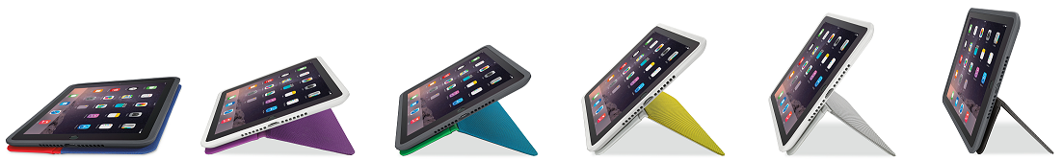
Press Contact
Leona Daňková
TAKTIQ COMMUNICATIONS s.r.o.
+420 605 228 810
leona.dankova@taktiq.com

