Fact Sheet

Logitech® G231 Prodigy Gaming Headset
Superior stereo audio and chat for console gaming

Announcement Date: Sept. 1, 2016 Shipping: September 2016
Price: 1 590 Kč Available at: gaming.logitech.com

Product Description
Using 40mm neodymium drivers, the Logitech® G231 Prodigy Gaming Headset delivers high-quality stereo sound that keeps you immersed in your PC and console game from start to finish. The headset features a lightweight, comfortable design, with washable performance-sport cloth earcups.

Key Features
- Game-quality stereo sound: Enjoy stereo sound for an immersive audio experience that complements the intense graphics of today’s games.
- Performance-sport cloth earcups and a lightweight design: Marathon gaming sessions mean heat and sweat, which is why these earcups on the G231 Prodigy Gaming Headset were designed with easily washable performance-sport cloth for a soft, comfortable fit even after long hours of use. The earcups are slimmer and lighter, so you might even forget you’re wearing a headset.
- On-cable controls: Puts volume and microphone mute within easy reach for quick, precise audio adjustments. The controls are attached to an extra-long, two-meter cable.
- Lie-flat earcups: For a personalized fit, the earcups swivel up to 90 degrees. And because they can turn to lie flat, they’re less prone to breakage from everyday wear and tear.

System Requirements
- Optional software download works with Windows® 7 and higher
- Powered USB port
- Internet connection and 100MB hard drive space (for optional software download)

Product Specifications
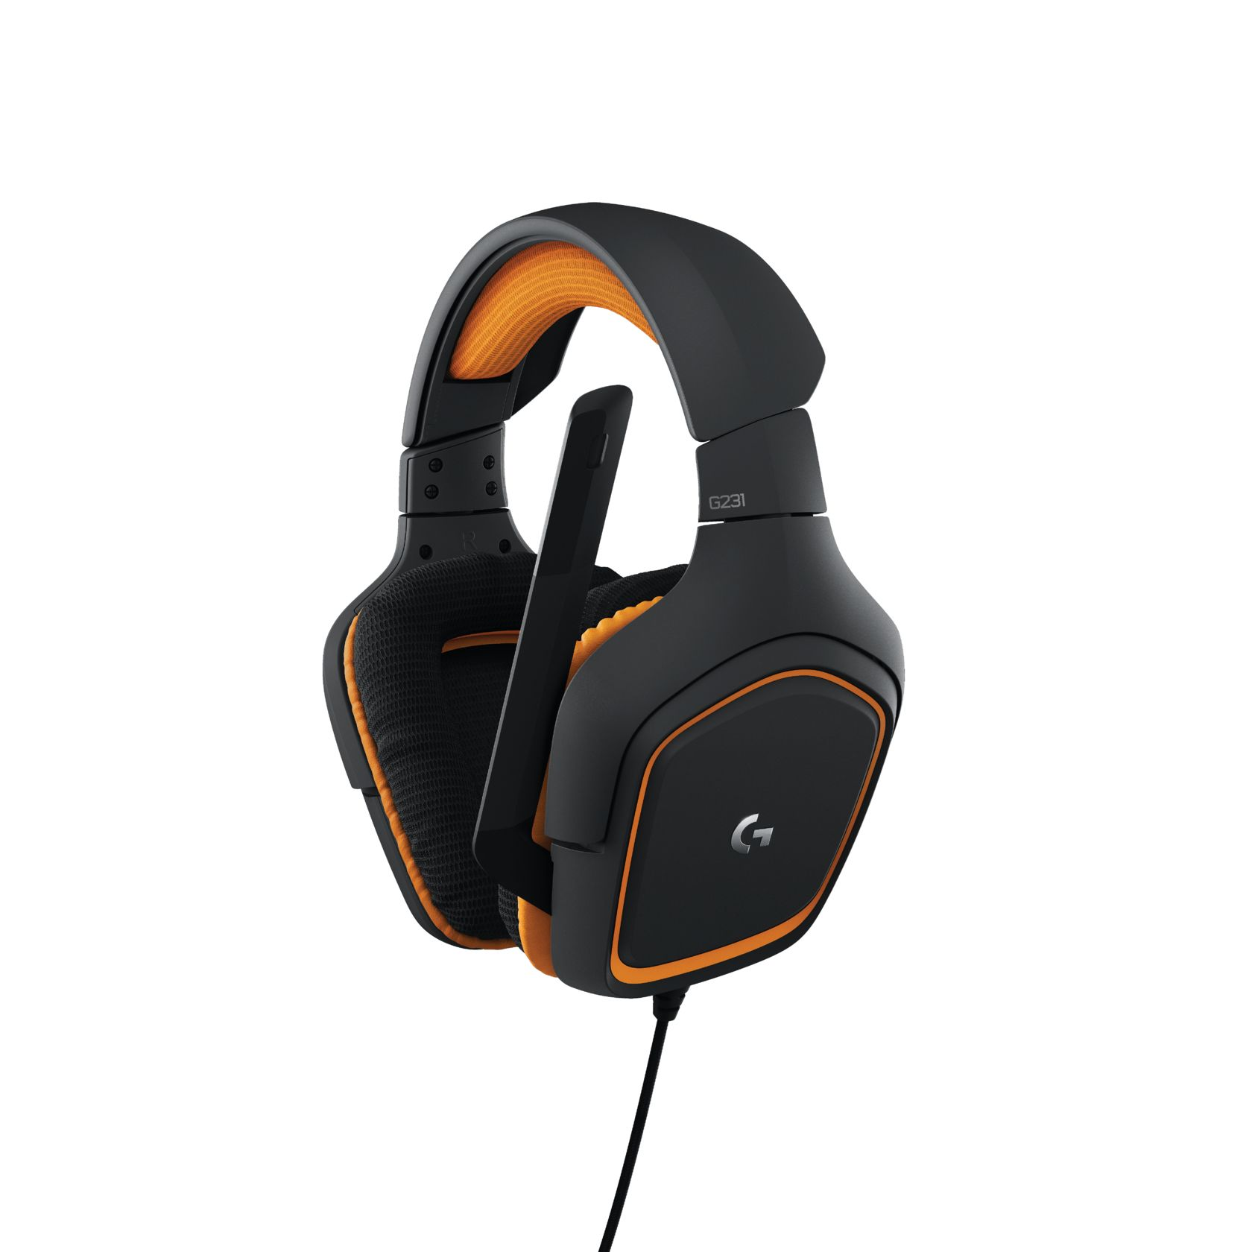
- Headphones
  - Driver: 40mm neodymium
  - Frequency response: 20Hz-20 KHz
  - Impedance: ~32 Ohms
  - Size: 190mm x 180mm x 94mm
  - Sensitivity: 90dB SPL/mW
- Microphone
  - Size: 4mm
  - Pickup Pattern: Cardioid (Unidirectional)
  - Frequency response: 50Hz-20KHz
  - Sensitivity: -40 dBV/Pa re: 0dB = 1 Pa, 1 KHz
  - Test conditions: 3.0V, 2.2K Ohm

Warranty
- 2-year limited hardware warranty

Press Contact
Leona Daňková
TAKTIQ COMMUNICATIONS s.r.o.
+420 605 228 810
leona.dankova@taktiq.com

