Fact Sheet

Logitech® G213 Prodigy™ RGB Gaming Keyboard
A sleek, spill-resistant gaming keyboard for everyday use

Announcement Date: Sept. 1, 2016 Shipping: September 2016
Price: 2 190 Kč Available at: gaming.logitech.com

Product Description
The Logitech® G213 Prodigy™ RGB Gaming Keyboard is a full-sized keyboard that features customizable RGB lighting, comfortable, responsive keys and dedicated media controls. It’s got a sleek, spill-resistant design, making cleanup quick and easy. An integrated palm rest and adjustable feet let you set your keyboard to the ideal position, so it feels perfect during extended gaming sessions. The Logitech G213 Prodigy Keyboard is ideal for gamers of any experience level.

Key Features
- Comfortable and Durable: The G213 Prodigy is a full-sized keyboard designed for gaming and productivity. The slim body is built for gamers of all levels, with a durable construction that is spill-resistant, so accidental splashes won’t ruin your keyboard. An integrated palm rest and adjustable feet let you set your keyboard to the ideal position, so it feels perfect during extended gaming sessions.
- Brilliant Colour Spectrum Illumination: Personalize five individual lighting zones from a spectrum of up to 16.8 million colours. Change colours to match your setup, specific games, or showcase your favourite colours, and synchronize lighting effects with other Logitech G devices using Logitech Gaming Software (LGS). Low light leakage around each keycap means more light comes through the lettering and less spills out around the keycaps, making it easier to find your keys in the dark.
- Performance Tuned with Multi-Key Input: The G213 Prodigy Keyboard brings together the best in tactile feel and performance with keys built specifically for the way gamers play. Each key is tuned to enhance the tactile experience, delivering ultra-quick, responsive feedback that is up to four times faster than standard keyboards. The anti-ghosting gaming matrix is tuned for optimal gaming performance, keeping you in control when you press multiple gaming keys simultaneously.
- Dedicated Media Controls: Control your background track without switching out of your game. The G213 Prodigy Keyboard features dedicated media controls that can be used to play, pause and mute music and videos instantly. Adjust the volume, or skip to the next song with the touch of a button.
- Customize with Logitech Gaming Software: Fully customize your G213 Prodigy Keyboard for added convenience and personalization with LGS. Set the RGB lighting colour and effect, save time by assigning macros to function keys (F1-F12), and much more.
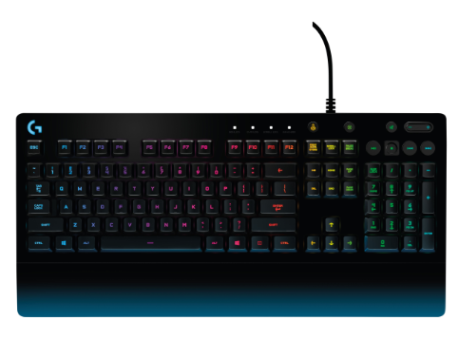

System Requirements
- Optional software download works with Windows® 7 and higher
- Powered USB port
- Internet connection and 150MB hard drive space (for optional software download)

Physical Specifications
- Dimensions (L x W x D): 218mm x 452mm x 330mm
- Weight: 1.1kg
- Cable length: 2m

Spill Resistance
- Tested with 60ml liquid spillage

Warranty
- 2-year limited hardware warranty

Press Contact
Leona Daňková
TAKTIQ COMMUNICATIONS s.r.o.
+420 605 228 810
leona.dankova@taktiq.com

