Fact Sheet

Logitech® C922 Pro Stream Webcam

Pro HD Webcam Designed for Serious Streamers

Announcement Date: Sept. 29, 2016 Shipping: October 2016
Price: 2 690 Kč Available at: www.logitech.com

Product Description
Designed for serious streamers, the Logitech® C922 Pro Stream Webcam gives you the tools to show your skills with superior clarity when you want to go live on TwitchTM and YouTubeTM. You can stream clear video in your choice of sharp 1080p at 30fps (frames per second) or fluid 720p at 60fps, and use the dynamic background replacement technology to integrate your live image in the game. And, the tabletop tripod with a swivel mount lets you adjust the webcam to the best possible angle when you’re broadcasting. A complimentary 3-month XSplit Premium license allows you to easily start streaming or recording your PC games to bring your gaming to life.

Key Features
- Full HD 1080p at 30fps / 720p at 60fps streaming: Stream and record vibrant, true-to-life HD 1080p video that captures the most exciting details with fast, smooth uploads with H.264 – advanced compression technology that demands less network bandwidth.
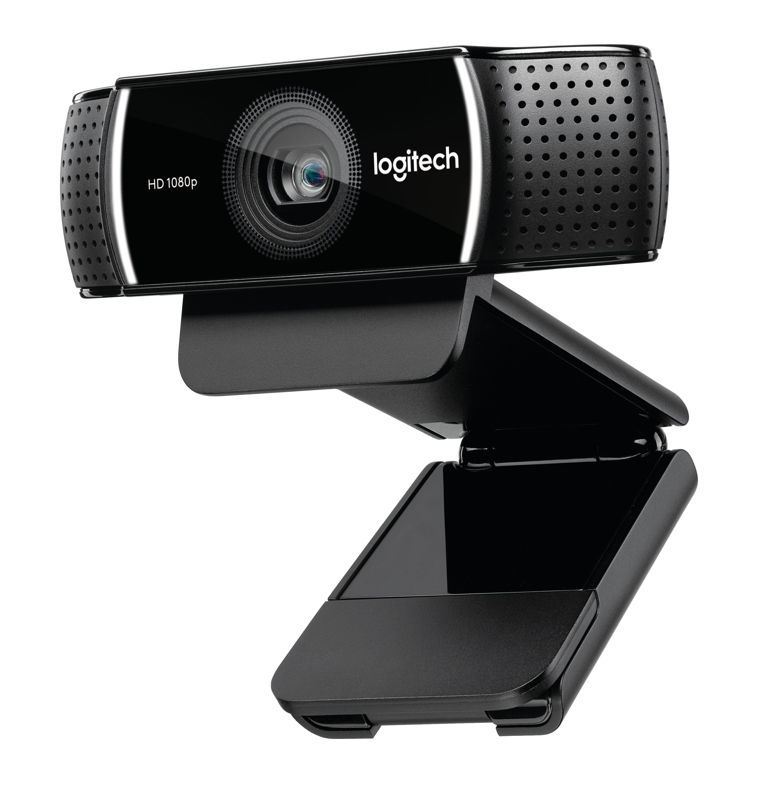
- Dynamic background replacement (powered by Personify): Integrate live images while broadcasting and interacting with your audience. This built-in advanced feature, available for the Windows® operating system, lets you build a visual theme for gameplay and stand out from the crowd.
- Tripod: Fully adjustable tabletop tripod with swivel mount extends to 18.5 cm.
- Automatic low light correction: Stream clear video even in dim light. Video automatically adjusts to accommodate flickering room lights or multiple computer screens.
- Capture stereo audio from every angle: Two omnidirectional mics capture stereo audio from every angle, ensuring clear, no-­drop streaming and recorded video.
- XSplit Premium License: A 3-month XSplit Premium license, available for the Windows operating system, is included and offers complete access to the professional-grade tools and features of both XSplit Broadcaster and XSplit Gamecaster so you can start streaming right out of the box.

System Requirements
- Windows® 10 or later, Windows® 8, Windows® 7
- Mac® OS X 10.9 or later
- ChromeTM OS and Android v 5.0 or above
- USB port
- Internet access

Product Specifications
Webcam
- Dimensions:
  - Height: 29mm – 43.5mm including clip
  - Width: 95mm
  - Depth: 24mm – 71mm including clip
- Weight: 162g
- H.264 and MJPEG video compression
- Full HD Glass lens (f=2.8) with 20-step autofocus
- 78 degree horizontal field of view
- USB cable: 6 ft

Tripod
- 360 degree swivel mount
- Extends from 110mm to 185mm

Warranty
- 2-year limited hardware warranty

Press Contact
Leona Daňková
TAKTIQ COMMUNICATIONS s.r.o.
+420 605 228 810
leona.dankova@taktiq.com

