Fact Sheet

Logitech® M720 Triathlon Multi-Device Mouse

A highly productive, versatile, and comfortable wireless mouse for multi-device and multi-OS use.

Announcement Date: Aug. 31, 2016 Shipping: September 2016
Price: 1 890 CZK Available at: www.logitech.com

Product Description
Built for endurance, versatility and comfort, the Logitech® M720 Triathlon Mouse helps you succeed in a multi-device world. The Easy-Switch™ technology lets you pair and switch seamlessly between three computers so you can power through tasks. With the hyper-fast scroll wheel, you can fly through documents and web pages, or shift to click-to-click scrolling when you need precision. Boosted power efficiency allows the mouse to run for up to two years on a single AA battery. Optimized for Windows® and Mac®, the M720 Triathlon features a full-sized sculpted shape that fits comfortably under your hand.

Key Features
- Easy-Switch technology: Pair M720 Triathlon with up to three devices, including 2-in-1 laptops and Android tablets. Then, the Easy-Switch technology lets you switch between each device with the touch of a button that is conveniently located under your thumb.
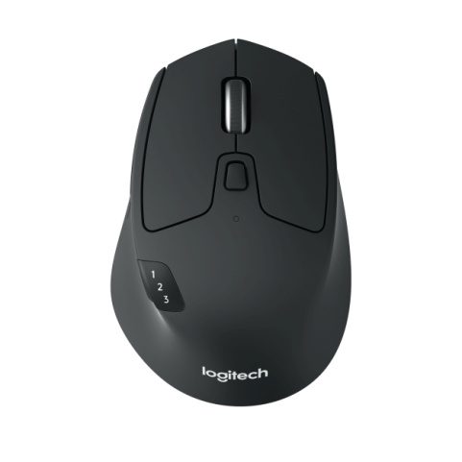
- Dual Connectivity: Connect this performance mouse via included Logitech Unifying™ Receiver or via Bluetooth® Smart wireless technology.
- Hyper-fast scrolling: Fly through documents and web pages using the hyper-fast scroll wheel, or shift to click-to-click scrolling when you need precision.
- Durable design: The M720 Triathlon is designed to last, with buttons built to withstand up to 10 million clicks.
- 24-month battery life: The M720 Triathlon delivers improved power efficiency and runs for up to two years on a single AA battery.
- Personalized productivity: Customize any button to your exact needs and experience a full range of possibilities of your mouse with Logitech OptionsTM software.

System Requirements
Bluetooth® Smart:
- Windows® 10 or later, Windows® 8
- Mac OS X 10.10 or later
- Chrome OS™
- Android 5.0 or later

Unifying Receiver:
- Windows 10 or later, Windows 8, Windows® RT, Windows® 7
- Mac OS X 10.05 or later
- Chrome OS
- Linux®

Product Specifications
- Mouse Dimensions:
- Height: 1.77 in (45 mm)
- Width: 2.91 in (74 mm)
- Depth: 4.53 in (115 mm)
- Weight (including battery): 4.76 oz (135 g)
- Number of buttons: 8
- Sensor technology: Logitech Advanced Optical Tracking
- Sensor resolution: 1,000 dpi
- Logitech Advanced 2.4 GHz wireless connectivity

Warranty
- 2-year limited hardware warranty (EMEA)

Press Contact
Leona Daňková
TAKTIQ COMMUNICATIONS s.r.o.
+420 605 228 810
leona.dankova@taktiq.com

