Fact Sheet

Logitech® M330 Silent Plus Mouse

A comfortable quiet mouse with a 24-month battery life and strong wireless connection.

Announcement Date: Aug. 31, 2016 Shipping: October 2016
Price: €39.99 Available at: www.logitech.com

Product Description
With the same “click” feel and over 90% noise reduction (verified by Quiet Mark™) when compared with the Logitech M170, the Logitech® M330 Silent Plus Mouse offers a quiet experience for you and your neighbors – whether at home or in the office. It has a long-lasting 24-month battery life with auto-sleep so it automatically puts itself to sleep when not in use, and a powerful 33-foot wireless range, depending on environmental factors, with 128-bit encryption between the mouse and the receiver. Plus, the mouse is designed with contoured grips that are made of soft rubber for total comfort. Just plug in the tiny USB receiver and it works with Windows®, Mac®, Chrome OS™ or Linux®. Logitech® Advanced Optical Tracking provides smooth and precise moves on almost any surface. The M330 Silent Plus is the first mouse to receive the Quiet Mark seal of approval from the Noise Abatement Society.

Key Features
- Work quietly: Experience the same “click” feel and over 90% noise reduction on the click sound. The M330 Silent Plus features a rubber wheel for quiet scrolling and the feet are made of high-performance material for quiet gliding.
- Crafted for your right hand: Enjoy extra comfort for your right hand with curved, soft rubber grips designed to fit the natural shape of your hand.
- 24-month battery life: With the M330 Silent Plus, you can go longer between battery changes because the mouse automatically puts itself to sleep when not in use.
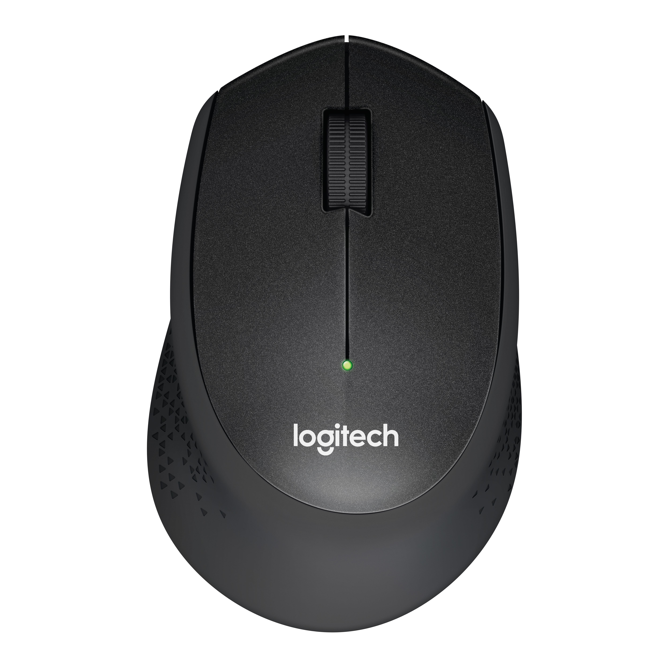
- Simple. Reliable. Strong: Enjoy a wireless connection up to 33 feet (10m) away, thanks to a plug-and-forget nano receiver. The M330 Silent Plus features Logitech Advanced Optical Tracking for ultra precise moves on almost any surface. No software needed. Works with Windows, Mac, Chrome OS or Linux-based computers.

System Requirements

Windows® 10, Windows® 8, Windows® RT, Windows® 7

Mac OS X 10.5 or later

Chrome OS

Linux Kernel 2.6+2

Powered USB port

Product Specifications
- Mouse Dimensions:
  - Height: 105.4 mm
  - Width: 67.9 mm
  - Depth: 38.4 mm
- Weight (including battery): 91.0 g
- Number of buttons: 3
- Sensor technology: Logitech Advanced Optical Tracking
- Sensor resolution: 1,000 dpi
- Logitech Advanced 2.4 GHz wireless connectivity

Warranty
- 2-year limited hardware warranty (EMEA and JP)

Press Contact
Ann Finnie
Logitech
1-510-713-5854
afinnie@logitech.com

