Fact Sheet

Logitech®G Pro Gaming Mouse
Fast, accurate and responsive mouse, designed with and for professional eSports players

Announcement Date: Aug. 16, 2016 Shipping: September 2016
Price: 2 190 Kč Available at: gaming.logitech.com

Product Description
Designed for eSports athletes, the Logitech G Pro Gaming Mouse features Logitech’s most accurate optical gaming sensor, a metal spring button tensioning system, onboard memory for driver-free operation on tournament systems, and a comfortable, durable, lightweight design. The Logitech G Pro Gaming Mouse builds on the heritage and global popularity of the Logitech G100s shape among top competitive eSports professionals, while delivering incredible speed, accuracy and responsiveness.

Key Features
- Advanced Optical Gaming Sensor: Consistent, pixel-precise accuracy makes a critical difference in high-stakes competitive gameplay. The PMW3366 sensor delivers a level of precision widely considered to be the best by enthusiasts and professionals alike. With zero smoothing, filtering or acceleration across the entire DPI range (200-12,000DPI), it provides exceptional tracking accuracy and consistent responsiveness at any speed.
- Metal Spring Button Tensioning System: The metal spring button tensioning system in the Logitech G Pro Gaming Mouse enhances the consistency of the left and right mouse buttons and helps reduce the force required to click. This ensures a crisp, reliable click performance you can depend on at the highest level of competition.
- Comfortable, Durable and Lightweight Design: The Logitech G Pro Gaming Mouse is optimized to reduce weight, helping improve comfort, stability and responsiveness. Every aspect of the engineering is rigorously tested to make sure it can stand up to even the most intense gaming. The top surface of the Pro Gaming Mouse is treated with a special coating to improve durability and grip, and the left and right buttons are tested to exceed 20 million clicks – the equivalent of a pro gamer training 10 hours every day for two years.
- Driver-free Operation for Tournament Systems. The Logitech G Pro Gaming Mouse lets you save your exact DPI settings, button assignments, and lighting configuration via Logitech Gaming Software (LGS) to the onboard memory in the mouse, so you'll never have to worry about whether your setup is right. Since you can't always guarantee the tournament machine will have your configuration software available, or that it's allowed to be installed, so this is perfect for competitions.

System Requirements
- Optional software download works with Windows® 7 and higher
- Powered USB port
- Internet connection and 100MB hard drive space (for optional software download)
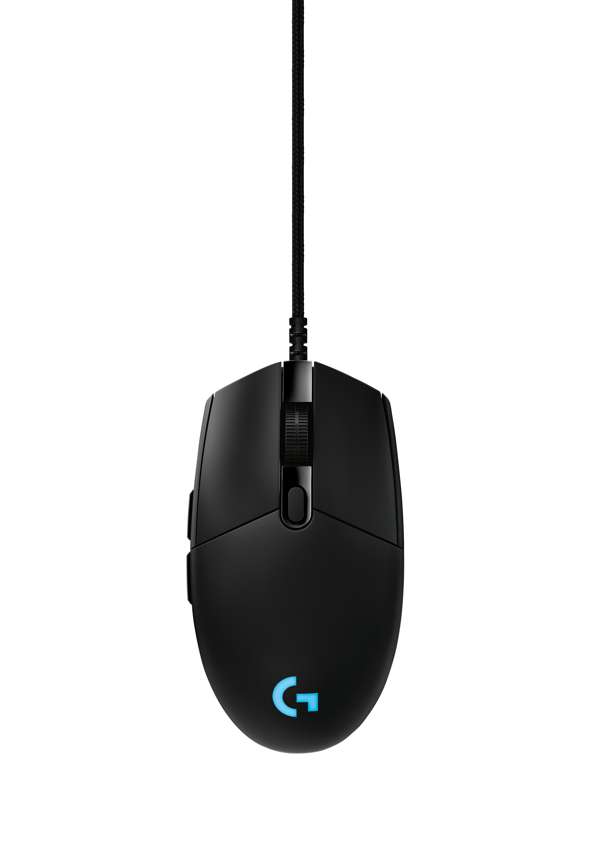

Physical Specifications
- Dimensions (L x W x D): 116.6mm x 62.15 mm x 38.2 mm
- Weight: 83 g (mouse only)

Tracking
- Resolution: 200 – 12,000 DPI
- Maximum acceleration: >40G*
- Maximum speed: >300 ips*

Responsiveness
- USB data format: 16 bits/axis
- USB report rate: 1000Hz (1ms)
- Wireless report rate: 1000Hz (1ms)
- Wireless technology: Custom 2.4GHz
- Microprocessor: 32-bit ARM

Glide
- Dynamic coefficient of friction**: .1 μ (k)
- Static coefficient of friction**: .16 μ (s)

Durability
- Buttons (Left / Right): 20 million clicks
- Feet: 25km

* Tested on Logitech G240 Gaming Mouse Pad
**Tested on wood-veneer desktop

Warranty
- 2-year limited hardware warranty

Press Contact
Leona Daňková
TAKTIQ COMMUNICATIONS s.r.o.
+420 605 228 810
leona.dankova@taktiq.com

