Fact Sheet

Logitech® K780 Multi­Device Wireless Keyboard
One Keyboard. Fully-equipped. For computer, phone and tablet.

Announcement Date: June 29, 2016 Shipping: June 2016
Price: 2 769 Kč Available at: www.logitech.com

Product Description
The Logitech® K780 Multi­Device Wireless Keyboard redefines what a desktop keyboard can do, letting you easily type on – and switch between – three connected devices, whether Windows® or Mac® and Android™ or iOS. You can write an email on your computer then touch an Easy-Switch™ button to reply to a text message on your phone or tablet. The keyboard design and layout, PerfectStrokeTM keys and 10-key number pad provide a comfortable and familiar typing experience, while the integrated cradle holds your mobile device at a stable reading angle. The K780 Multi-Device comes with a Logitech Unifying™ USB receiver or Bluetooth® Smart technology so you can choose the best way to connect.

Key Features
- Type on anything: The K780 Multi­Device is compatible with any computer, smartphone or tablet. Start typing on your computer, then switch and type on your phone or tablet – at the touch of an Easy­Switch button.
- All the keys you need, with PerfectStroke typing: Experience quiet and comfortable typing with large, carefully crafted concave keys in a full-size and familiar layout, including a 10-key number pad.
- Mobile device cradle: An integrated cradle holds a variety of devices – from smartphones to the iPad ProTM – at the perfect reading angle.
- OS-adaptive: The K780 Multi­Device adapts to the operating system that is connected, and automatically maps keys to supported functions and shortcuts.
- Dual connectivity: With the K780 Multi-Device, you can choose the best way to connect the device. It comes with a Logitech Unifying USB receiver and Bluetooth Smart technology.

Product Specifications
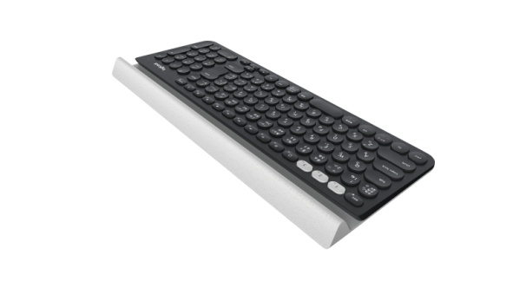
- Dimensions
  - Height: 22 mm (Large end) and 8 mm (Slim end)
  - Width: 380 mm
  - Depth: 158 mm
- Weight: 875 g

Warranty
- 2-year limited hardware warranty for EMEA

Press Contact
Leona Daňková
TAKTIQ COMMUNICATIONS s.r.o.
+420 605 228 810
leona.dankova@taktiq.com

