Fact Sheet

UE ROLL 2
Better, louder, stronger.

Announcement Date: May 24, 2016 Shipping: May 2016
Price: €99 Available at: www.ultimateears.com

Product Description
UE ROLL 2 is the most convenient, anywhere-you-go-proof wireless speaker that allows you to take your music wherever, whenever. The perfect musical companion for your next adventure, UE ROLL 2 is equipped with a bungee cord loop and is waterproof, so you can attach it on your bike or bag and take it with you, making it the ultimate companion you can hang in the shower, bring to the beach or throw in the pool. UE ROLL 2 is 15 percent louder than the original UE ROLL and has a wireless range of 100-feet. With its completely waterproof design (IPX 7 certified), UE ROLL 2 comes with its very own UE Floatie in every package, so your speaker can float right through the fun and splash up next to you at your pool party. The new and improved speaker keeps the same, sleek, disk-shape design of UE ROLL, packing in even more without adding extra size or bulk.

Key Features
- Even better sound: UE ROLL 2 blasts out 15 percent more sound, delivering epic tunes in the palm of your hand.

- Stick it on and bring it wherever: With its sleek, disc-shaped design, UE ROLL 2 offers portability and versatility like no other speaker. With its bungee cord loop, UE ROLL 2 is designed for life’s adventures. You can attach to anything - from your belt loop, to your backpack, to your beach umbrella – making it great for when you’re on the move and for when you get to where you’re going.

- No seriously, it’s waterproof: With its IPX 7 certified waterproof rating, UE ROLL 2 can be completely submerged in water and withstand your craziest pool party. The perfect musical companion for your next beach bash or pool party, you can rest easy knowing your favorite playlist won’t be interrupted by life’s splashes or spills.

- Bigger, better, louder: UE ROLL 2 packs in even more than the original UE ROLL, delivering epic tunes in the palm of your hand with 15 percent more sound and an extended wireless range of 100-feet. By improving the wireless range and sound, music lovers can enjoy even more freedom and flexibility.

- Unlock new experiences: Thanks to the free UE ROLL app for iOS® or Android™, you can enjoy Block Party, which lets you and two friends share songs through the same speaker. You can also double up the sound of your UE ROLL 2 by paring it with other UE speakers, wake up to your favorite tunes through the alarm clock and even turn your speaker on and off remotely.

System Requirements
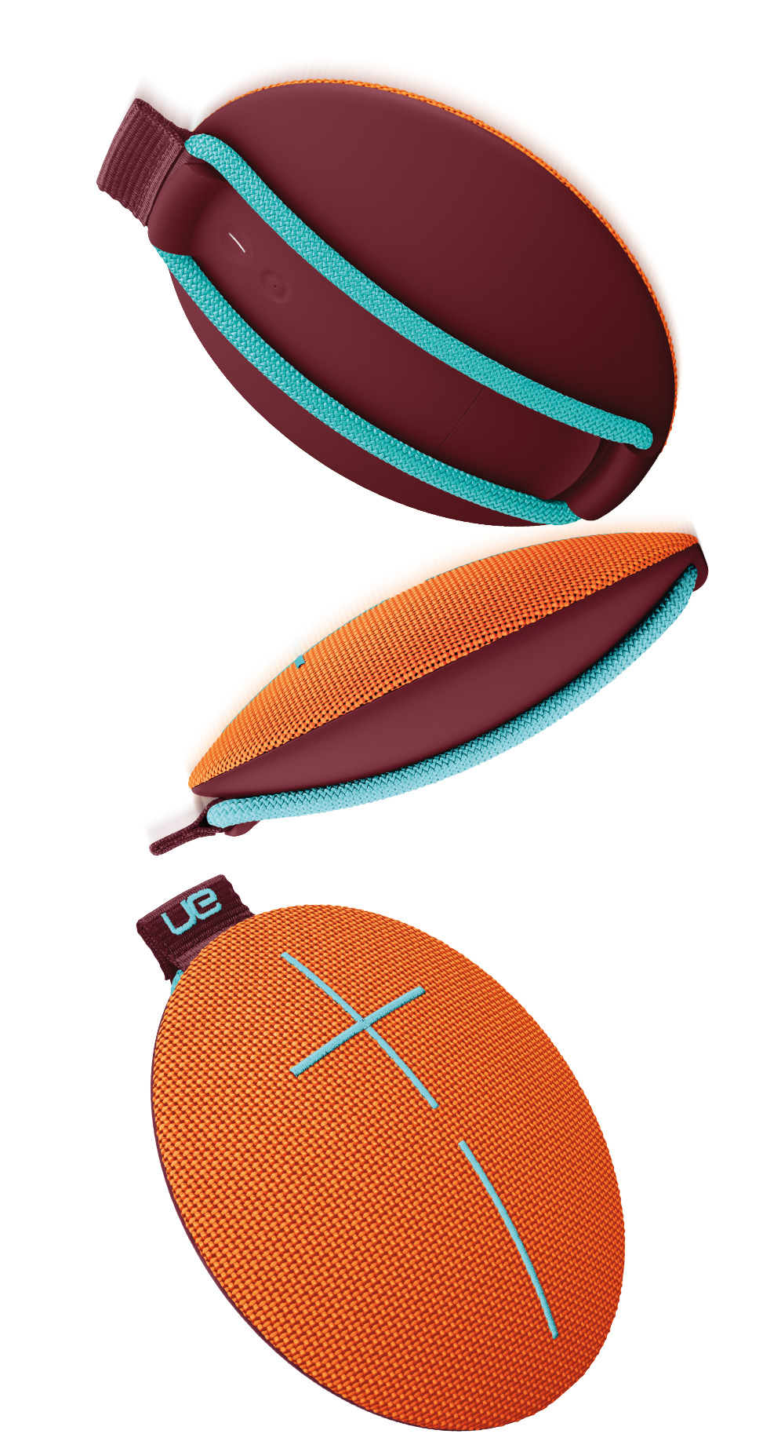
- Smartphones, tablets and other devices that support Bluetooth and Bluetooth Smart® wireless audio profile (A2DP) or 3.5 mm audio input

Product Specifications
- Height: 40mm
- Diameter: 135mm
- Weight: 12 oz.

Warranty
- Two-year limited hardware warranty

Press Contact
ADD LOCAL CONTACT

*Actual wireless range and battery life will vary with use, settings and environmental conditions.

